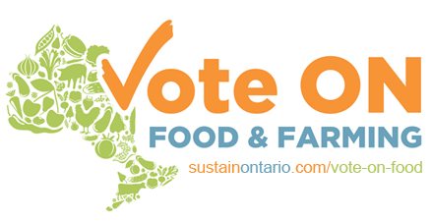
Good Food and Farming Ideas for Ontario
Election 2018
Make food and farming
a priority this election



Support local food and farm enterprises

Ensure that public dollars go to purchasing Ontario food and farm products
- Enact Local Food Act targets requiring public sector organizations to purchase 20% Ontario products, with incentives and supports to increase to 40% by 2022.

Facilitate access to capital for provincial food and farming entrepreneurs
- Implement a tax credit which allows ordinary people to move their RRSPs into a community project investment
- Commit Social Enterprise Strategy funds to support innovative and sustainable food enterprises
- As with public roads, use public funds to invest in food infrastructure to achieve long-term rural development goals

Support Sustainable Farming by Enabling Future Farmers and Preserving Farmland

Support Ontario’s new farmers
- Provide stable core funding for existing and expanded on-farm training programs, providing apprenticeship and mentorship for new entrants and diversifying farms
- Make publicly-owned farmland available to new graduates of farmer training programs
- Work with farmers to develop programs that provide long term access to farmland for new and young farmers

Support farmland preservation
- Place strict controls on speculation in, and commodification of, Ontario farmland by prohibiting the acquisition or control of class 1-4 farmland in the province by non-farmer and/or absentee investors

Incentivize and support sustainable farming practices
- Measure soil organic matter on Ontario farms every three years, and tie these soil health indicators directly to farmland taxation rates and crop insurance subsidies

Get Healthy Food into Schools and the Curriculum
Establish a universal school nutrition program
- Continue to support and expand the Ontario Student Nutrition Program

Enable food literacy education for all students in grades K-12
- Strengthen the conditions for food literacy to be taught as a mandatory part of the curriculum

Engage School Boards in advancing good food in schools
- Ask school boards to develop food literacy and student nutrition policies

Support Community Growing
Establish community-led standards for accessibility
- Support and fund communities to develop practical accessibility standards for new or retrofitted community gardens, whether on public or private property
Help implement AODA standards
- Create a provincial fund to implement Accessibility of Ontarians with Disabilities Act (AODA) standards for new or retrofitted community gardens
Support soil testing policies that enable community growing
- Develop and implement a process for soil testing with standards that create favourable conditions for the development of community garden
Enable all Ontarians to Access Healthy Food

Set appropriate standards and gather evidence
- Develop and adopt transparent and regionally appropriate calculations of social assistance rates to include the cost of a nutritious food basket in all areas of the province
- Commit to consistent participation in Household Food Security Survey Module of Canadian Community Health Survey

Prioritize poverty reduction
- Increase social assistance rates linked to the real cost of living, utilizing the recommendations from Income Security: Roadmap for Change report
- Continue and evaluate the Ontario Basic Income Pilot Project
- Create policies that encourage good jobs with regular hours and benefits, including raising the minimum wage to $15 / hour

Use healthy food to serve health needs
- Implement a program to provide fresh food prescriptions to people with chronic health issues, included in the pharmacare plan

Bold Game Changer:
The Ontario Food Policy Council

- Establish a Provincial Food Policy Council that will connect the work of similar regional and municipal food policy councils, indigenous councils and provincial food systems actors, with a mandate to support a National Food Policy Council
#voteonfood

Good Food has the power
to make change

