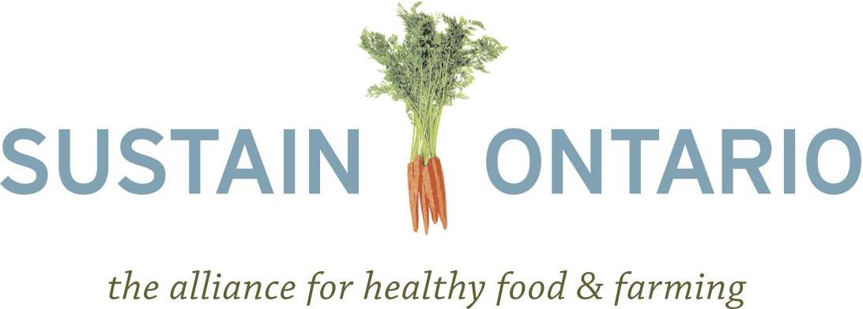
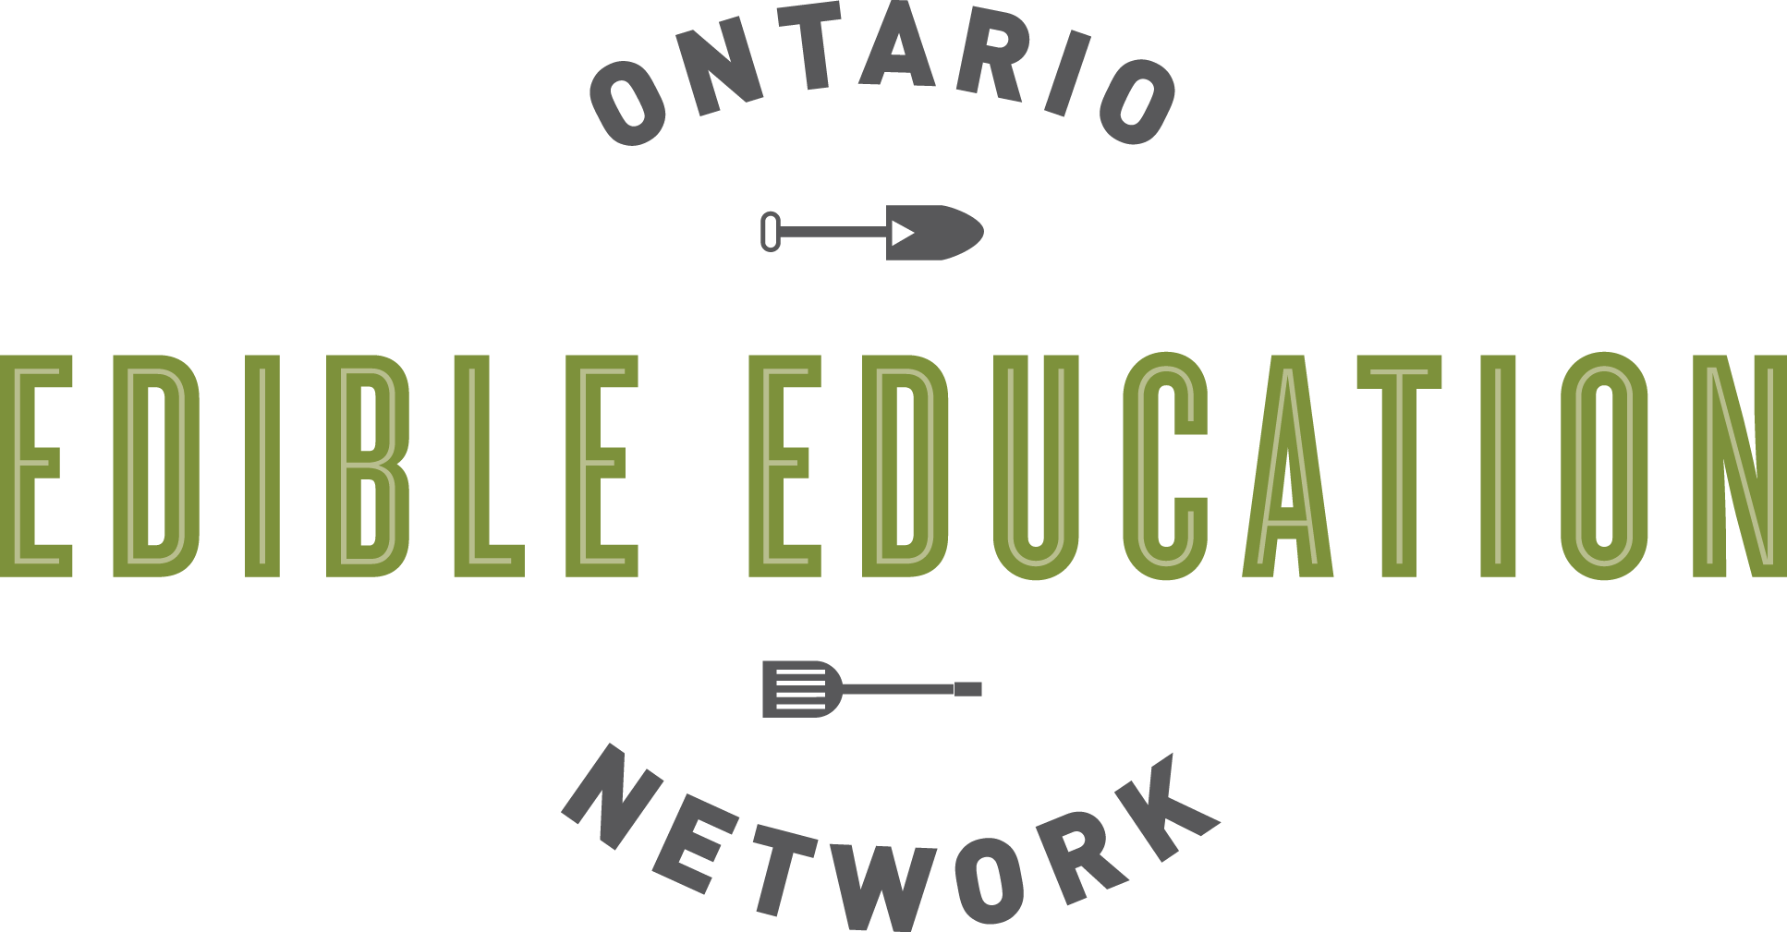

Backgrounder on Food Literacy, Food Security, and Local Food Procurement in Ontario’s Schools

October 2013

Introduction
This backgrounder presents how an integrated approach to addressing food literacy and food security in Ontario’s schools would provide a broad range of health, economic, educational, and other benefits. Specifically, taking a whole-school approach to healthy eating and ensuring that food literacy and local food procurement complement the existing Ontario Student Nutrition Program would support the wellbeing of children and youth, and advance the Government of Ontario’s policy priorities

The recommendations in this backgrounder have been written for consideration by Ontario policy makers. The paper is also intended to support and lend ideas to the many on-the-ground initiatives taking place across the province that aim to advance one or more of the document’s interrelated themes.

Our Current Opportunity
Citizens and governments across Ontario are currently working to address a host of interrelated challenges:
- With more than a quarter of children between the ages of 2 and 17 overweight in Ontario, increasing numbers of youth are at risk of developing respiratory disorders, orthopedic conditions, cancer, heart disease, adult diabetes, high cholesterol and type 2 diabetes.
- For many students, breakfasts, snacks or lunches provided by student nutrition programs are the only meal or the only healthy meal eaten during the day.
- Lack of self-efficacy and food skills are barriers to making healthy food choices.
- Small- and medium-sized farmers face significant threats to their livelihood, which has economic impacts across the province.

In recent months the Government of Ontario has been developing a number of policy approaches to support these issues including (a) the renewal of the Ontario Poverty Reduction Strategy, (b) the Healthy Kids Panel report and recommendations, (c) the proposed Local Food Act, and (d) building the next phase in Ontario's Education Strategy.
This moment provides a unique window in time for the Government to develop an integrated approach to the challenges facing our province and to support the future health and wellbeing of today’s children and youth.

Defining Student Nutrition Programs and Food Literacy
Student nutrition programs provide a variety of nutritious food and beverage choices for breakfasts, lunches and snacks to students before, during or after each school day. Student nutrition programs complement efforts to improve the eating habits of children and youth as well as reduce rates of childhood obesity and the incidence of overweight children.

Food literacy involves understanding:
- where food comes from;
- the impacts of food on health, the environment and the economy; and
- how to grow, prepare, and prefer healthy, safe and nutritious food.

While these two facets complement one another, student nutrition / breakfast programs focus on providing children and youth with food so that they are not hungry when they are in school, while food literacy education engages children and youth to learn skills and develop habits that will enable them to make healthy food choices throughout their lives.

How do student nutrition and food literacy contribute to a better Ontario?

SNPs and food literacy reduce the incidences and costs of diet-related illness
The health of our children is a growing concern. The report No Time to Wait: A Healthy Kids Strategy, which was submitted in 2013 by the Healthy Kids Panel to the Ontario Ministry of Health and Long-term Care, raises the alarm that childhood obesity is at a crisis in Ontario.
- Between 1978 and 2004, the prevalence of obesity and overweight in Ontario children increased about 70 per cent. The proportion of 12- to 17-year-olds who are overweight increased from 14 per cent to 29 per cent and, of those, the proportion who are obese tripled (3 per cent to 9 per cent). At this rate, by 2040, 70 per cent of children will be obese.
- Increasing numbers of youth are at risk of developing respiratory disorders, orthopedic conditions, high cholesterol and type 2 diabetes due to poor diet. Unhealthy eating habits from childhood often extend into adulthood, amplifying the cost for the Ontario health care system of treating associated illnesses. It is predicted that 75 per cent of obese children grow up to become obese adults, costing Ontario's health-care system an estimated $4.5 billion in direct and indirect costs.

This issue is a product of our current food systems and surrounding food environments. A quick fix will not help.

Schools, where students consume one third of their daily calories, are in a unique position to impede this trend, particularly by employing prevention-oriented strategies that foster good dietary habits.
- Schools can provide students with both an opportunity to consume healthy foods, and also to develop the knowledge and skills needed to make healthy food choices for life.
- Findings consistently show that student nutrition and food literacy programs result in students eating more fruits and vegetables per day in the cafeteria, classroom, or at home; that these programs result in students making positive lifestyle changes; and that they improve knowledge and attitudes about healthy eating.

SNPs and food literacy improve academic attendance and performance
For many children and youth, breakfasts, snacks or lunches provided by student nutrition programs are the only meal or the only healthy meal that they eat during the day. A vast body of evidence shows that student nutrition programs contribute significantly to reducing tardiness and illness, to improving students’ behaviour in class, and to improving students’ abilities to concentrate, retain and apply information.

SNPs and food literacy provide children with essential life skills
A lack of self-efficacy and self-perceived poor food skills have been identified as barriers to making healthy food choices and as leading to greater reliance on pre-prepared foods. Student nutrition programs and food literacy education in the school system present opportunities for students to gain the necessary skills to make healthy food choices and increase their self-efficacy to prepare nutritious meals for themselves.
- Teaching food skills within the education system is important, as children are not always provided with food skills or knowledge at home.
- Making food literacy part of the mainstream school curriculum is supported by 95% of Ontarians.
- Student nutrition programs have the potential to go beyond providing meals and snacks. Food provides an avenue for education on a wide variety of topics.

Food focused activities such as food gardens, food skills, and cooking programs help to bring education to life for children and youth, especially when linked to the curriculum. By taking learning outside of the classroom and into real-world settings children and youth become more engaged in learning about topics from math and science to English and history and gain useful and marketable skills.
- Many teachers have learned the incredible potential of school gardens as a fun educational vehicle for virtually every subject area. “They allow students to become familiar with the challenges and rewards of growing food. In many cases students also learn how to prepare the products of their labour into nutritious and tasty meals.”
- In a study conducted by Evergreen, 91 percent of survey respondents involved in their school food gardens felt that the garden fostered awareness and appreciation of nutritious food, and 89 percent felt that the gardens were providing important opportunities for physical activity.

And yet, only 0.5 percent of Canada’s 16,000 schools have food gardens. In contrast, 10 percent of schools in the UK and 30 percent of California schools have food gardens.

SNPs and food literacy have the potential to enhance Ontario’s economic resilience
Nutrition programs, culinary programs, cafeterias and contracted food service providers in Ontario schools purchase millions of dollars of food annually. Ontario has a lot to gain by supporting public institutions to buy local, sustainably produced food.
- Shifting some of the dollars spent towards purchasing Ontario food would create new markets for Ontario products and support the local economy.
- Strengthening institutional purchasing would build up a predictable base of demand for local food and provide opportunities to help rebuild local food infrastructure.
- For small- to medium-sized farmers, farm-to-school programs can be a new market, an additional source of income, a meaningful way to become a part of the community, and an outlet to educate future consumers and potential farmers about agriculture.
- In the long-term food literacy education and exposure to healthy foods may contribute to students growing accustomed to fresh, local food and ensure that they will prefer Ontario food in the future. As with recycling and smoking cessation it has also been shown that children and youth can influence their parents’ purchasing behaviours.

Recommendations for the Government of Ontario for a Whole-School Approach to Food Literacy and Food Security

- Create a provincial food literacy and student nutrition policy framework
- Based on a provincial policy framework, ask school boards to develop mandatory food literacy and student nutrition policies. The policy will inform programs and curriculum initiatives that deepen student food literacy and nutrition knowledge, enabling children and youth to live healthier lives.

- Provide teacher training and support other infrastructure that enable food literacy to be taught using the Ontario curriculum and for it to be integrated into other aspects of the school environment
- Include evidence-based food literacy, education about nutrition, food, growing and producing food, and food skills development as a mandatory part of the curriculum at all grade levels.
- Ensure that new teachers are taught to make curriculum links to food literacy in many different subject areas at all grade levels.
- Provide and support teacher training and professional development in the area of food literacy.
- Develop a set of age-appropriate food skills / food literacy benchmarks and a common evaluation for cooking skills and culinary programs.

- Support the establishment of gardens, composters and food skills programs in schools as complimentary experiential programs that support and reinforce in-class food literacy education
- Build all new elementary and secondary schools with food skills infrastructure, a full-service cafeteria, and a food garden.
- Provide resources and enact supportive policies to enable existing schools to build and maintain gardens, greenhouses, food skills programs, and cafeterias.
- Ensure hands-on food skills education in schools.
- Identify opportunities for resource sharing between schools and community agencies, such as garden educators and rotating food skills educators.

- Develop local procurement policies for schools
- Develop local food procurement policies and targets for schools and support schools to build these requirements into contracts with food suppliers.
- Provide incentives, training, funding and other support to enable schools to meet the procurement targets.
- Support collaboration with public health units to provide both health protection and health promotion training related to local food procurement.

- Ensure that all children and youth have access to healthy and nutritious food in schools
- Ensure that all Ontario schools run a Student Nutrition Program that is accessible to every child and youth every school day.
- Advocate for the federal government to provide greater support for Student Nutrition Programs in First Nations communities.
- Advocate for the federal government to play a cost sharing role in supporting provincial Student Nutrition Programs that serve all children and youth.

There exist a number of additional supports outside of schools that would help ensure that children and youth can access enough healthy and culturally appropriate food. These include:
- Support public health and community-based programs outside of the classroom that educate children and youth about healthy eating and teach food literacy
- Support programs where food skills and food literacy, including planning, shopping, cooking, preparation, preservation, food storage and food safety, are taught as part of extra-curricular activities.
- Support community food access solutions that promote the availability and affordability of fresh, locally or regionally grown foods and create opportunities to scale these up throughout the province (e.g. fresh vegetable and fruit boxes and community gardens).
- Prioritize food focused jobs in existing youth summer employment initiatives
- Support programs that enable children and youth to visit farms and community food initiatives.

- Reduce child and youth exposure to marketing of foods and beverages
- Create a policy framework to protect children and youth from targeted advertising of food and beverages,

- Support additional mechanisms to ensure food security for all families in Ontario
- Put in place additional measures to ensure that families have access to fresh and healthy food regardless of their socioeconomic status. These may include supportive policies to improve individual and household income, as well as using the cost of the Nutritious Food Basket in determining the rates for social assistance and the minimum wage and in the formation of ODSP/Social Diet Allowance payouts.

Immediate Mechanisms for Policy Makers to Implement these Recommendations:
Develop broad strategies and frameworks:
- Support the implementation of an Ontario Food and Nutrition Strategy to ensure an integrated and complimentary approach to reducing hunger, supporting healthy eating, reducing chronic disease and health-related illnesses, and addressing other aspects of our food system.
- Develop a provincial food literacy and student nutrition policy framework. Require that school boards develop a mandatory food literacy and student nutrition policy. Even better, require the development of a healthy schools policy that integrates healthy eating and food literacy with physical activity, environmental stewardship, and healthy communities.
Through the Local Food Act:
- Continue to implement policies that ensure the procurement of local, fresh and sustainable foods into schools, addressing the nutritional needs of children and youth with the additional benefit of supporting Ontario’s economy. (along with Healthy Kids Strategy)
- Embed a requirement for food literacy education in our schools.
- Develop local food procurement policies and targets for schools and support schools to build these requirements into contracts with food suppliers.
- Provide incentives, training, funding and other support to enable schools to meet the procurement targets.
- Support collaboration with public health units to provide both health protection and health promotion training related to local food procurement.

As a part of the Education strategy:
- Ensure that new teachers are taught to make curriculum links to food literacy at all grade levels and that this area is an option for professional development.
- Fund and support other education and health-based programs, such as school gardens and food skills and culinary programs. Promote curriculum links to these programs and provide related teacher training.
- Establish age-specific food literacy and food skills benchmarks and expectations along with appropriate evaluation methods.

Through the Healthy Kids Strategy:
- Continue to support Student Nutrition Programs until all Ontario schools have the funds and infrastructure needed to run a Student Nutrition Program that is accessible to every child and youth. (along with Ontario Poverty Reduction Strategy)

Through the Ontario Poverty Reduction Strategy:
- Support policies to improve individual and household income to enable low-income residents to afford healthy food (e.g. adequate minimum wage and social service allotment, affordable housing, affordable childcare, seniors care, public transportation, education and training, and employment).
- Ensure access to nutritious food for all Ontarians by using the cost of the Nutritious Food Basket (calculated annually by each Public Health Unit) in determining the rates for social assistance and the minimum wage and in the formation of ODSP/Social Diet Allowance payouts.
- Support community food programs (initiatives that help individuals and families not only access healthy food but also learn how to prepare it and make healthy food choices).

Ontario Ministry of Heath and Long-term Care. 2013. No time to wait: The healthy kids strategy [Ontario]. Toronto, Canada. Available online: http://www.health.gov.on.ca/en/common/ministry/publications/reports/healthy_kids/healthy_kids.pdf.
Ontario Ministry of Heath and Long-term Care. 2013. No time to wait: The healthy kids strategy [Ontario]. Toronto, Canada. Available online: http://www.health.gov.on.ca/en/common/ministry/publications/reports/healthy_kids/healthy_kids.pdf.
Joshi, Anupama, Andrea Misako Azuma, & Gail Feenstra. 2008. Do Farm-to-School Programs Make a Difference? Findings and Future Research Needs. Journal of Hunger & Environmental Nutrition, Vol. 3. Available online: http://www.cahpf.org/GoDocUserFiles/504.Farm_to_School_Programs.pdf.
Muthuswamy, E. 2012. “Feeding Our Future: The First- and Second-Year Evaluation.” Toronto District School Board.
Tufts University Center on Hunger, Poverty & Nutrition (1994). Nutrition Policy. Retrieved from the Ontario Student Nutrition Program website. Available at: http://www.osnp.ca/menu.php?list=595&page=135. And American Dietetic Association et al., (2003). Retrieved from the Ontario Student Nutrition Program website. Available at: http://www.osnp.ca/menu.php?list=595&page=135.
Health Canada, 2010. “Improving cooking and food preparation skills: A synthesis of the evidence to inform program and policy development. Available online: http://www.hc-sc.gc.ca/fn-an/nutrition/child-enfant/cfps-acc-synthes-eng.php.
Health Canada, 2010. “Improving cooking and food preparation skills: A synthesis of the evidence to inform program and policy development. Available online: http://www.hc-sc.gc.ca/fn-an/nutrition/child-enfant/cfps-acc-synthes-eng.php.
FoodShare. 2010. “Ontario Online Polling Results.” Strategic Communications Inc.
Wittman, Hannah, Annette Aurélie Desmarais & Nettie Wiebe. 2011. (eds.) Food Sovereignty in Canada: Creating Just and Sustainable Food Systems. Fernwood Publishing: Black Point, N.S.
Bell, A., Dyment, J. 2006.
Bell, A., Dyment, J. 2006. “Grounds for Action: Promoting Physical Activity through School Ground Greening in Canada.” The Toyota Evergreen Learning Grounds Program. Available online: http://www.evergreen.ca/docs/res/Grounds-For-Action.pdf.
Waterloo Region Food System Roundtable. 2012. Priorities for Waterloo Region’s Food System. Available at http://www.wrfoodsystem.ca.
See Policy and Design used by the Vancouver School Board on Gardens: http://www.vsb.bc.ca/district-policy/io-garden-policy.
FoodShare. 2010. “Canadians Demand Federal Action on Childhood Nutrition, National Food Policy.” Press Release.
Toronto Youth Food Policy Council. 2010. “Community Meeting on Food Literacy.” November 2010 Community Meeting Notes.
Unhealthy foods and beverages include those that are high in saturated fats, trans-fatty acids, sugars and sodium.
See the Quebec Consumer Protection Act of 1980 which prohibits commercial advertising directed at children under the age of 13.
The Ontario Collaborative Group on Healthy Eating and Physical Activity is preparing a model Ontario Food and Nutrition Strategy (OFNS) in collaboration with Sustain Ontario as a member of the design team. The OFNS has been informed by broad stakeholder consultation and is intended to provide a coordinated, cross-ministerial approach to food policies and programming in the province of Ontario. The OFNS is available at: http://sustainontario.com/initiatives/ontario-food-and-nutrition-strategy.
See the D.C Healthy Schools Act for a model of a law designed to support the comprehensive health and wellness of students: http://dchealthyschools.org/.

