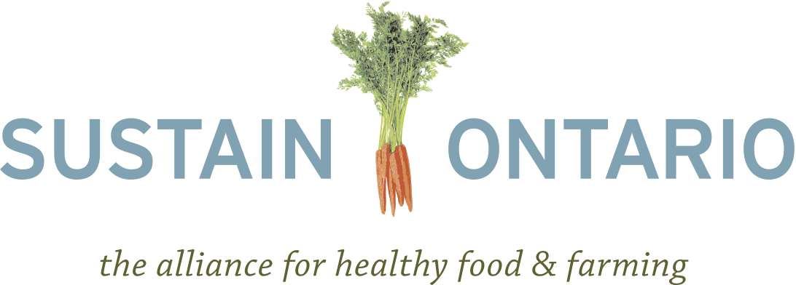

Backgrounder on Regional Food Hubs
July 31, 2012

Introduction

This backgrounder reviews some of the essential contributions that regional food hubs make towards sustainable regional food systems and recommendations that the Ontario government should adopt to incorporate regional food hubs into the proposed Local Food Act.

The definition of a regional food hub is a “business or organization that actively manages the aggregation, distribution, and marketing of source-identified food products primarily from local and regional producers to strengthen their ability to satisfy wholesale, retail, and institutional demand.” This organization or business could range from physical infrastructure for the aggregation and distribution of regional food to online regional food networking platforms and other alternative brokerage models.

How do regional food hubs contribute to a better Ontario?

Economic Robustness

Regional food hubs satisfy many concerns about the food system currently expressed by Ontario farmers and consumers alike. Having food hubs closer to small- and medium-sized farming operations provides them with increased market access opportunities and helps fulfill growing consumer demand for regional food. This demand for regional food comes not only from consumers, but from institutions like schools and hospitals as well. Aggregating food from multiple small and medium producers allows institutions to procure the volume of regional food that they require from one place. Regional food hubs also offer farmers marketing and branding opportunities that they may lack the ability to provide for themselves.

Additionally, the wealthiest and most sustainable communities are those that are the most self-reliant and have the highest percentage of jobs in businesses that are locally owned. And economics shows that the more a dollar circulates in a defined region the more income, wealth and jobs it creates. This phenomenon known as the multiplier effect of buying local has been well studied in Ontario. For example, it is estimated that if every household in Ontario spent $10 a week on regional food, we’d have an additional $2.4 billion in the provincial economy at the end of the year and create 10,000 new jobs. Regional food hubs contribute to the independence of regions and therefore to their sustainability and wealth. This can be especially impactful in food deserts where low-income populations may live.

Environmental Impact Reduction

Regional food hubs are better for the environment and better for Ontario’s self-reliance as localizing the buying and selling of food means that it travels less far, creating less dependency on oil to move food from farm to plate. Regional food hubs promote the production of food with environmental well-being and regeneration in mind, demonstrating a strong commitment to Ontario’s environmental goals.

Increasing Food Access

Regionalizing food hubs re-establishes farm to city linkages that have long been lost as our food is produced further afield and citizens lose sight of where their food comes from and what to do with it. Regional food hubs have also proven to increase access to fresh food in ‘food deserts’ or communities typically underserved by fresh food. This aspect appeals to health professionals and consumers alike as increased access to fresh food may reduce the currently astronomical incidences and costs of diet-related illness in Ontario.

Some food hubs also incorporate a social justice aspect into their business model which may include programs like community gardens, fresh food boxes, community kitchens, and farmer’s markets that work to both increase access to and educate underserved consumers about fresh food.

Lastly, and perhaps most innovative, regional food hubs may eventually allow for the breaking down of barriers that are currently burdensome to certain communities. Examples include the boreal wild game hunt of concern to Northern Ontario’s Aboriginal population, or redundant trade of concern to Ontario producers. As regional food hubs are community-based and scaled, they will allow for the development of community-appropriate practices that currently present a difficulty.

How are current regulations affecting Ontario’s food processors?

Existing regulations have been developed in the context of large-scale production, resulting in barriers for smaller scale, local producers. In the case of Ontario abattoirs, many operations that close down cite concerns related to costs driven by a regulatory system seen as excessive, insensitive and focused on large processor issues. For example, the cost for inspecting a small number of livestock in a small abattoir is the same as the cost for a large plant. Additionally, no distinction is made between upgrade costs and compliance timelines for large and small-scale operations. As navigating food legislation and regulations can be very complicated, many processors hire lawyers to help understand the relevant rules, after which some are only able to proceed with partial compliance, and others decide not to launch their businesses at all.

Examples of Success in Ontario

100km Foods Inc.
Aggregates and distributes Ontario foods to food service and retail thereby increasing market access for small and medium sized farming operations.

FoodShare
The Good Food Box and student nutrition programs increase access to healthy and local foods for students and low-income individuals.

Pfenning’s Organic Farm
Focuses on community building, growing organic produce as well as aggregating and distributing as much regional produce as possible.

Recommendations for Supporting Food Hubs

Support regionally developed initiatives
- Recognize the different needs and assets of each community that will impact on the design of a regional food hub.
- Support communities and entrepreneurs in developing a food hub design appropriate to their individual context.
- Ensure that the management and operations of regional food hubs remains the prerogative of the food hub’s consumers, operators, farmers and stakeholders.

Access to financing
- Support both new and existing food hub initiatives.
- Provide start-up and improvement/enhancement capital through grants and loans to food hub operators for warehouses, equipment and business development (logistics, branding, marketing).
- Work with financial institutions to develop loan options for innovative business models like cooperatives.

Simplify production and processing regulations.
- Create an agri-food secretariat or ombudsman who reports to the Ontario legislature to review and/or hear complaints on outdated or burdensome regulations and work to eliminate/simplify those that can be.
- Continue the Open for Business process for the agricultural and food sectors.
- Foster greater communication between ministries on agricultural issues.

Create the infrastructure necessary to enable the development of regional food hubs
- Increase the capacity of and continue the Rural Economic Development Fund (RED) Program, the Ontario Market Investment Fund (OMIF), and the Broader Public Sector Investment Fund (BPS). Expand these programs to include a greater focus on food hubs.
- Adopt procurement policies that would result in the purchase of more regional food.
- Ensure that a large portion of funding that supports purchasing from regional food hubs is directed toward keeping the food in the region.

Foster networking and partnerships
- Establish and expand knowledge networks for producers through farmer organizations, extension programs, a food hub operator best practices guide and farmer-to-farmer field schools.
- Establish an alliance of small and medium-sized food processors that use regional products.
- Support the creation of online food hub communities for those regions where producers are geographically isolated from one another.

Engage retailers
- Provide incentives and public recognition for retailers who source food from regional food hubs.

Create an environment favourable to regional food processing
- Establish food safety regulations appropriate to the scale of processing enterprises and support for compliance.
- Stimulate agricultural processing enterprise zones to extend tax relief and credits to food processors.

Barham, J., D. Tropp, K. Enterline, J. Farbman, J. Fisk, and S. Kiraly. 2012. “Regional Food Hub Resource Guide.” U.S. Dept. of Agriculture, Agricultural Marketing Service. Washington, DC.
Barham, et al. 2012.
Barham, et al. 2012.
Shuman, M. 2010. “The Competitiveness of Local Living Economies,” in The Post Carbon Reader Series: Economy. The Post Carbon Institute: California.
Shuman, M and D. Hoffer. 2007. “Leakage Analysis of the Martha’s Vineyard Economy: Increasing Prosperity through Greater Self-Reliance.” Training and Development Corporation.
See economic impact reports of buying local for regions throughout Ontario conducted by Harry Cummings and Associates published online: http://www.hcaconsulting.ca/Projects/AgricultureandRuralDevelopment.aspx.
Ogryzlo, L. 2012. “$10 Challenge, Billion Dollar Impact.” The Ontario Table. Available online: http://www.ontariotable.com/10-challenge-billion-dollar-impact/.
Barham, et al. 2012.
Carter-Whitney, M. and the Canadian Institute for Environmental Law and Policy. 2008. “Bringing local food home: Legal, regulatory, and institutional barriers to local food.” Friends of the Greenbelt Foundation Occasional Paper Series.
Federated Women's Institutes of Ontario. 2011. "Meeting with Minister Mitchell." Briefing Notes.
Ibid.
Ibid.
Dunster, C., et al. n.d. "Food laws demystified: enabling the good food sector to comply with food law."
Barham, et al. 2012
Barham, et al. 2012.
Personal communication from a 31 May 2012 meeting of various agri-food stakeholders organized by the Green Education Council in Guelph, ON.
Carter-Whitney, M. 2008.
Carter-Whitney, M., Miller, S., Canadian Institute for Environmental Law and Policy. 2010. “Nurturing Fruit and Vegetable Processing in Ontario.” Metcalf Food Solutions: The Metcalf Foundation.
Ibid.
Ibid.

