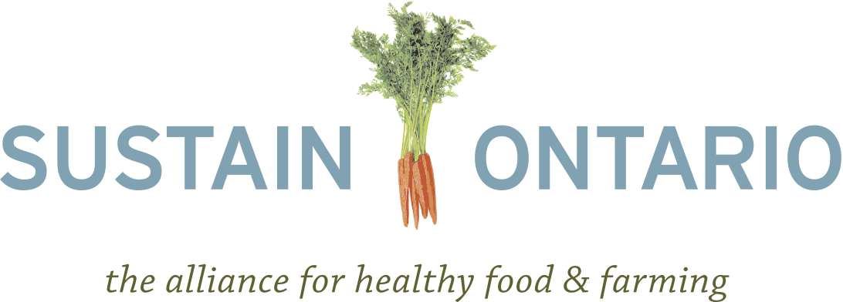

Briefing Note on Policies to Support Local Food
December 2012

Sustain Ontario is strongly supportive of comprehensive local food policy including an expansive Local Food Act. We support policies that promote systemic changes to encourage procurement of food that is local, fresh and produced in a way that uses renewable resources, builds soil and soil capacity, and diversifies agro-ecosystems to ensure the environmental, economic, health and social well-being of future generations (using ecological practices). Such policies would support to our domestic agricultural and processing industries, encouraging job growth and economic development within the province. It would also have tremendous spin-off benefits for education, health and environmental quality.

The Food and Farming Sector is already an economic driver in Ontario. Food processing and farming employs as many Ontarians as the auto sector. Hundreds of rural communities depend on jobs created through agriculture and food. The $1.2 billion fruit, vegetable, and meat sector represents: 7,500 fruit and vegetable farmers and their families, 30,000-plus non-family on-farm jobs, 19,000 cattle farmers, 2,800 hog farmers. Further, Ontario is home to 3,500 food processors that contribute more than $32.5 billion to the economy and employ almost 120,000 people.

This sector still has room for significant growth. From 1998 to 2008, Ontario’s food sector grew by approximately 2–3% a year, but the food economy sub-sector defined as local, organic, specialty, and/or ethnic foods, grew at a much faster rate—estimated at 15 to 25% per year. Local food has the potential to grow even further. It is estimated that if every household in Ontario spent $10 a week on local food, there would be an additional $2.4 billion in the local economy and 10,000 new jobs would be created.

One area that illustrates the potential is the organics sector, which has been growing at 15 to 20% per year since the 1990s. Currently, Canadian organic growers only produce 15% of what we consume, with most organics imported from the U.S..

Local Food Policy Recommendations

1) Enable the on-going development of innovative solutions
Develop a mechanism to align the work of Ministries whose activities, practices and decisions affect local food systems.
Create an independent group of experts to provide on-going advice, guidance, and direction on provincial food policy. The group should be made up of experts from health, agriculture, environment, food processing and distribution, education, and food access.
Increase the health promotion budget from 0.35% of the total provincial budget to 0.5%.

2) Reduce future health care costs and build markets for local food through schools
Create a provincial food literacy and student nutrition policy framework, with a requirement for all school boards to develop a food literacy and student nutrition policy and other programs and curriculum initiatives that deepen student food literacy and nutrition knowledge, enabling them to live healthier lives.

3) Increase markets for local, fresh, and ecologically produced food by increasing public procurement
Establish tracking and reporting mechanisms for institutions to measure the use of fresh, local and ecologically produced food.
Support institutions in strategically crafting requests for proposals for food tenders so as to a) utilize the exemptions available in relevant trade agreements and b) make requests that are not subject to trade agreements.
Maintain and expand the Broader Public Sector (BPS) Investment Fund. Ensure that this fund and other complimentary funds such as the Rural Economic Development (RED) program support networking, learning, and innovation, new food processors, aggregators and distributors, as well as established food companies.
Create a micro granting program to incentivize alternative distribution by farmers, including cost share programs for mini-refrigerator vans, refrigerated food displays for markets, and other small-scale distribution solutions.
Continue funding for further development of the Ontariofresh.ca web based food connection service.

4) Increase the capacity of local food and farming enterprises to grow the economy
Work with banks to create mortgage and loan programs for new and re-strategizing farmers and food businesses.
Create investment tools such as the Community Economic Development Investment Funds in other provinces to enable ordinary Ontarians to invest in local food and farming.

5) Support the growth of the fastest growing segment of the food market, the ecological and organic farming sectors
Continue the Environmental Farm Plan Program, and expand it to include, on a cost share basis, the conversion from conventional to organic and ecological growing techniques.
Increase the OMAFRA research budget by 10% and allocate the increased amount to specifically address challenges and opportunities for ecological and organic agriculture and forest and freshwater food systems. The above-mentioned advisory panel should help to guide and direct this additional research budget.
Develop and champion mechanisms to support farmers in unearthing value from ecological goods and services that result from ecological farming activities, farmland preservation and wildlife preservation. These mechanisms should include community- based models (e.g. ALUS), quantification techniques to accurately value ecological services, and third party certification systems that measure the value of ecological services.

6) Ensure that Locally Grown Food can get to market
Support the development of Regional Food Hubs and Clusters through a funding program to be delivered over 3-5 years.
Develop and deliver a funding stream to enable community based food access programs (good food boxes, food banks, good food markets, community kitchens, community food centres, etc.) to source local food.

7) Ensure protection of important forest and fresh water food sources vital to the well-being of northern communities
Support the development of education programs, curriculum and tools to raise awareness of the values and benefits of forest and fresh water foods.
Provide for inter-ministerial cooperation to address the conservation and sustainable use of forest and fresh water foods, including fisheries.

Greater Toronto Area Agriculture Action Committee (GTAAAC) (2011). Food & farming: An action plan 2021. Food and farming in the Golden Horseshoe. Page 2.
Baker, L., Campsie, P., & Rabinowicz. (2010). Menu 2020: Ten good food ideas for Ontario. Prepared for Sustain Ontario. Available at: http://metcalffoundation.com/wp-content/uploads/2011/05/menu-2020.pdf Page 16
Ontario Ministry of Agriculture Food and Rural Affairs (OMAFRA) (2011). Start, Manage and grow a business: Food processing. Food industry facts. Available at: http://www.omafra.gov.on.ca/english/food/industry/newbusiness.htm
Donald, B. 2009. "From Kraft to Craft: innovation and creativity in Ontario's Food Economy". Available online http://martinprosperity.org/media/pdfs/From_Kraft_to_Craft-B_Donald.pdf/
Ogryzlo, L. 2012. “$10 Challenge, Billion Dollar Impact.” The Ontario Table. Available online: http://www.ontariotable.com/10-challenge-billion-dollar-impact/
MacRae, R., Juhasz, M., Langer, J., & Martin, R. C. (2006). Ontario goes organic: How to access Canada’s growing billion dollar market for organic food. Prepared from World Wildlife Fund Canada & the Organic Agriculture Centre of Canada. Available at: http://www.organicagcentre.ca/ResearchDatabase/res_oos_intro.asp

