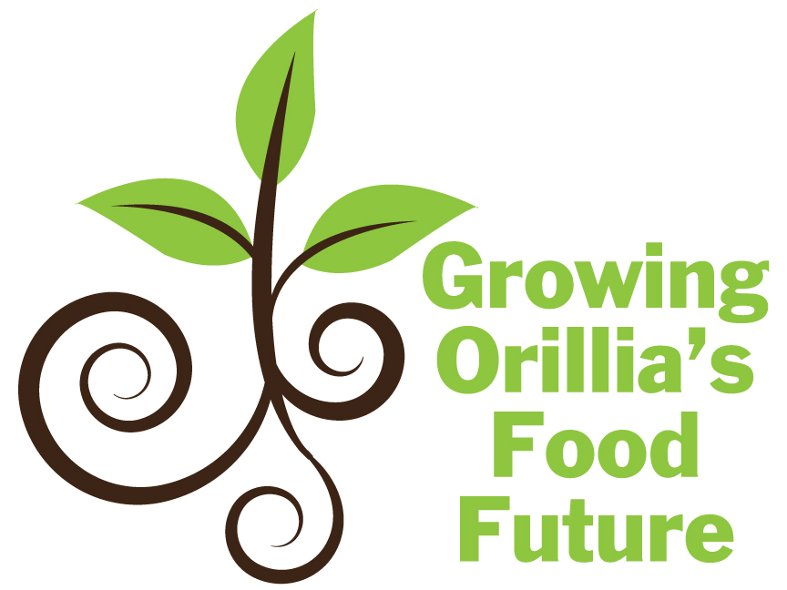

DECEMBER 31, 2013 COMMUNITY REPORT

Table of Contents
Foreword............................................................................................................................... Page 3
List of Tables………………………………………………….………………………...... Page 2
Background and Nature of the Issue ………………………………………………… ...Pages 4-7
Current Policy Actions……………………………………………………………… ......Pages 8-9
Community Stakeholder Survey………………………………………………………Pages 10-27
Moving Forward....................................................................................................................Page 28 Individual and Youth Survey………………………………………………………… Pages 28-31
Appendix A: Individual Survey………….………………………………………………...Page 32
Appendix B: Community Stakeholder Survey……..………………………………… .......Page 33
Appendix C: Contact List for Follow up……………………………………………….......Page 34

List of Tables
Table 1. Community Stakeholder Organizations and Programs.………….……..Pages 13- 19

Foreward

The following report is a preliminary exploration of food security in Orillia. There are many groups not represented here and voices not heard in this report, especially from those most affected by the food crisis. Building on this report, we intend to further this research and our collective understanding of these issues.
Please note that this research and report was conducted and prepared in a short time frame. We greatly appreciate the efforts of our Lakehead University student team (Lyndsey Chapman, Ashley Statham, Katie Taylor and Tyler Phil) and the community participation in this special process. The Community Stakeholder organizations and programs are the beginning of a comprehensive information source.
The intent behind this phase of the project was to spark a community conversation about food security, food access and food policy, and to gather and display quality ideas from those on the front lines of hunger in our communities. With the food access map and report in hand we will now confidently enter the next stage of food policy development, from ideas to action.
We eagerly invite you to join us in Growing Orillia’s Food Future! For further questions on this report, or to contribute to our project, please contact us via info@informationorillia.org .

Christine Hager, Executive Director, The Sharing Place Food Bank
Jacob Kearey-Moreland, Cultivator, Orillia Community Gardens.
(Growing Orillia’s Food Future - Project Directors)

Background and Nature of the Issue
What is food security?
Simply put, food security exists when all people at all times have access to sufficient, safe and nutritious food that allows for a healthy and active life. Food security includes food availability, food access and food use. This means that there is food insecurity when insufficient quantities of food are available, when there are insufficient resources to obtain food for a nutritious diet and also when knowledge about basic nutrition is not readily circulated and accessible. On a local scale, Orillia is in trouble on this measure. In the past 12 months, The Sharing Place Food Bank has handled almost 16,000 visits from community people who cannot afford to purchase food. These people are representative of many demographics: children, the unemployed, the working poor, families, seniors on fixed income, people in receipt of limited Ontario Works or Ontario Disability Support Payments, post secondary students struggling with education debt. Food bank use presents a mere piece of the puzzle in the problem of food insecurity for many individuals and families in Orillia.

What is food policy?
Food policy is about many things, but overall it is about how one relates to food, whether it is structured or unstructured. In structured terms, a public food policy addresses how food is produced, processed, distributed, and purchased. Such policies are designed to influence the operation of the food and agriculture system. Personal views about food shopping, food preferences and food consumption would be considered unstructured terms.

What is the Simcoe County Food and Agricultural Charter?
The Simcoe County Food and Agricultural Charter has been adopted by the county to create awareness and to foster participation in a food secure future for Simcoe County. It is not a policy document, but rather a guide for making decisions intended to improve the local food system for all residents of Simcoe County. The charter recognizes that food is essential for life and optimal health and that there are many members of the community who face barriers when attempting to access nutritious food. The following six principles are the founding values of the Simcoe County Food and Agriculture Charter and encourage actions that will result in a fair and food secure system for all:

- Equal Access to Healthy and Personally-Acceptable Food for All
- A Close-Knit Community Achieved through a Celebration of Food and Culture
- Long-Term Economic Growth and Prosperity
- Agricultural Sustainability
- Environmental Responsibility
- Increased Education and Skills Development for a Healthier Community

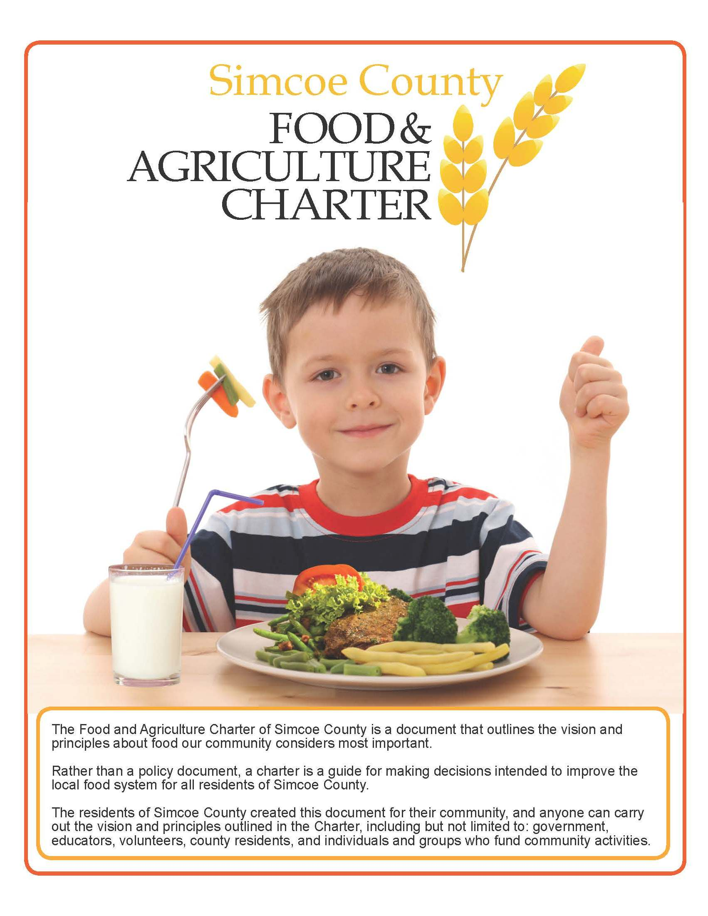

What is Growing Orillia’s Food Future?
The Sharing Place food bank in partnership with Orillia Community Gardens was awarded a grant through the Simcoe Muskoka District Health Unit – Healthy Community Partnership fund to initiate the development of food policy in the City of Orillia. Growing Orillia’s Food Future is a joint initiative to move Healthy Eating policy forward in our community. Building upon the Simcoe County Food and Agriculture Charter and the Severn Sound Sustainability Plan, Growing Orillia’s Food Future represents the next phase – from words to actions. In addition to recommendations ranging from simple to complex, Growing Orillia’s Food Future includes a visual map of Orillia’s food assets including, but not limited to food banks, soup kitchens, community kitchens, meal programs, community gardens, farmers markets and more located within the city limits. Local food policy, drafted for and by the community, will empower the upsurge of grassroots projects with practical solutions. Growing Orillia’s Food Future will underline the need to support both equal food access and the production of food in healthy, ecological and economically sustainable ways.

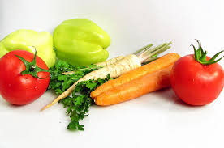
Current Food Policy Actions
Growing Orillia's Food Future is working towards having food policies and programs created that will improve the well-being of those in the local community. Food security is not currently present in Orillia, but there are policies and programs around Ontario which contribute to healthy eating and accessible food. The following are some of the Ontario supports in regards to healthy and accessible food:
- Ontario Local Food Act
The Ontario Local Food Act will give farmers a 25% tax credit, based on the fair market value, as an incentive to donate surplus crops to food programs and services. Farmers will be more likely to donate the crops they are unable to sell, thereby increasing the amount of fruits and vegetables food programs can offer to those in need. This will directly impact The Good Food Box and The Sharing Place food bank, as well as increasing nutrition for the latter.
- School Food and Beverage Policy
In effect since 2011, the School Food and Beverage Policy addresses the types of food offered to students in schools across Ontario. It sets requirements that schools must follow regarding the types of food they offer to students. This policy is creating a better learning environment for students by reducing the amount of poor nutritional food accessible to youth on a daily basis. Studies have shown that students perform better when they are eating balanced and nutritional meals.
- Barrie Fruit Share
Barrie Fruit Share is a project which benefits both property owners and the community. Volunteers harvest the fruit from trees on property whose owners have agreed to participate in the program. The collected fruit is shared with the tree owners, food bank, and the volunteers. Not only does this provide fresh fruit to the community but it also is a solution for all the fruit that falls off trees each year and spoils.
- Orillia Community Gardens
Several community gardens are located within Orillia. These gardens belong to the community and are run by dedicated volunteers who plant, cultivate, and harvest the crops. There is no single ownership of these gardens, rather it is for those in the collective community.
- Healthy Community Design Policy Statements for Official Plans
Ontario municipalities decide how their community will utilize their land through their Official Plans. Simcoe Muskoka District Health Unit has created a document which offers suggestions to municipalities during their planning sessions. The document goes over planning policies as well as short term, intermediate term, and long term implementation activities.
- 2013 Best Practices in Local Food
The 2013 Best Practices in Local Food is a guide for municipalities and offers ways to promote food initiatives in the local community. The content introduces the guide, how to get started, best practices, customizing practise, as well as implementing and measuring.
- The Simcoe County Food and Agriculture Charter
As noted previously, this charter outlines the vision and principles about food that we consider most important. Rather than a policy statement, it acts as a guide to decision making to improve the local food system for Simcoe County residents.
These are just some of the progressive initiatives around Ontario addressing food security for all people. Initiating a Barrie Fruit Share model would be an incredible opportunity in Orillia. It is clear that promoting a healthy diet is of concern across the province; Growing Orillia's Food Future is one of many movements to make our community the best it can be.
Community Stakeholder Survey
Objective
In addition to individual and youth surveys, we conducted a survey of the key stakeholder organizations in Orillia who are involved in combatting food insecurity. The community stakeholder survey had four objectives: (i) to create a comprehensive list of the organizations in Orillia that are involved in addressing food security, (ii) to find out what is already being done through these organizations to address food security, (iii) to generate suggestions from key organizations that can inform the creation of a municipal food policy, and (iiii) to use the survey information to develop a comprehensive visual food map of Orillia that includes food access points.
Sampling and Data Collection
Initially, the surveys were distributed to individual representatives of the organizations through three community meetings organized by The Sharing Place Food Bank (SPFB) and Orillia Community Gardens (OCG) with the support of the Simcoe Muskoka District Health Unit. The purpose of the meetings was to start a community conversation about food security, and to start developing ideas for a local food policy. In addition to paper surveys, the survey was set up online through SurveyMonkey™ in order to increase accessibility and convenience.
Attendance at the meetings was inconsistent, so we decided to also administer the survey by phone . We attempted to contact 30 organizations that were known to be involved in food security in some way. Of the 30 organizations, we were able to gather information from 14. A future attempt to gather information from the remaining organizations is highly recommended as this project is carried forward. We did not include all the food security related programs in Orillia because we were not able to survey all of the organizations.
Survey Questions
The survey questions were intended to help identify the programs and resources pertaining to food security in Orillia, and to gather important suggestions from these agencies for creating a municipal food policy for the city of Orillia. A copy of the community stakeholder survey can be found on page 33 in Appendix B.

Findings
Food Security Programs
We were encouraged to learn about many amazing organizations that are working hard with different populations to address food security. We noticed significant community determination to combat this issue, and that the organizations that participated were very enthusiastic about this project. The 14 agencies that we surveyed comprehensively provide services for all ages and stages; from babies to the elderly. In response to our fourth question, all the organizations deemed food security to be either somewhat or very important to their organization’s mandate.
The existing community programs spanned a wide variety of topics and needs including,: education about healthy eating, emergency food provision, and combined education with food provision. Programs ranged from pre-natal nutrition, baby food making classes, emergency food assistance, community kitchens and gardens, snack and lunch programs in schools, to affordable meals on wheels programs for seniors. Table 1 provides an overview of the food security related projects that are carried out by the organizations that participated in our survey.
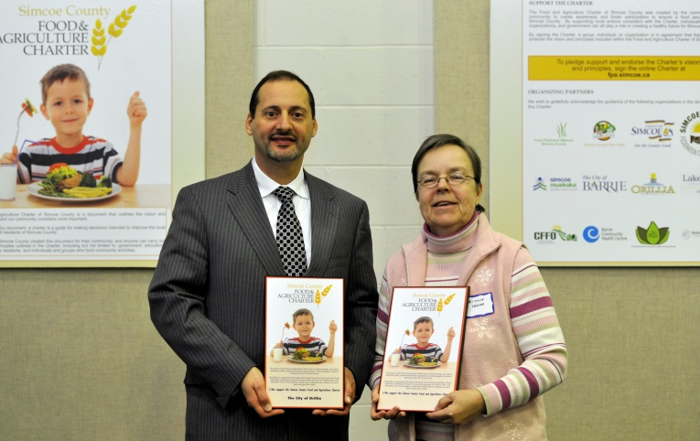 Charter Endorsement

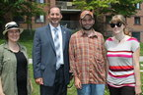
Orillia Community Garden celebration

Table 1. Community Stakeholder Organizations and Programs
Name of Organization | Population Served | Programs Related to Food Security | Schedule of Programs | Contact Information
Big Brothers Big Sisters | Children and youth, single parent families, low-income families. | Healthy Eating and Food Choices:  Programs for children between the ages of 12-15. Programs address healthy eating and nutrition, and how to eat healthy on a small budget.  Go Girls and Game On:  Programing for girls and boys 12-15 years of age. Address self-esteem, nutrition, body image, and leading a healthy lifestyle. | Schedule varies. Contact organization for more information. | Phone:  (705) 325 3151
Helping Hands | 65+ (Seniors) | Hot and Cold Meals on Wheels:  Provide seniors with meals in their home. The cost is $4.50/meal.  Call in advance to order, or come into office to pick up frozen foods.  Transportation Program:  Helps seniors access food. Round trip transportation to the grocery store for $8.00. Client can request that a volunteer accompany them. | Hot Meals Service: Monday, Wednesday, Friday. Food is dropped off between 3:15 and 4:15pm. | Phone:  (705) 325-7861  Address:  210 Memorial Ave, Unit 126B  L3V 7V1

Good Food Box | All ages. | Good Food Box Program:  Provides the opportunity for people in Orillia to buy fresh, local fruits and vegetables at a low cost. | Good Food Box:  Order and pre-pay.  Monthly Pickup:  Guardian Angels Church Hall on the 3rd Wednesday of every month, year round. | Call Information Orillia:  (705) 326-7743  for additional pick up and order information and locations.
Information Orillia | All ages. | Information Hub:  For all things related to food security.  Good Food Box:  Pickup and order location.  Grow a Row:  In partnership with The Sharing Place Food Bank, engage youth volunteers to plant seedlings that are planted in the community gardens. Volunteers take seedlings home and continue to grow them there. | Good Food Box:  Pick up on the 3rd Wednesday of every month.  Grow a Row:  Contact for annual schedule. | Phone:  (705) 326-7743  Address:  36 Mississaga St. West  L3V 3A6
Ontario Early Years Simcoe North | Families and children 0-6 years of age. | Emergency Baby Cupboard:  Include emergency provision of diapers, formula, baby food, and pabulum.  Drop in Play:  Snack is provided. | Emergency Baby Cupboard: Families can access once a week. Can be accessed by anyone without identification.  Drop in Play:  Tuesday to Saturday. | Phone:  (705) 325-1299  Address:  80 Colborne St. W  L3V 2Y7

Orillia Alternative High School | Youth 16 to 18. | Daily Snacks:  Students have access to school fridge at all times for snack and lunch. Fridge stocked through community partnerships.  Cooking and Nutrition Courses:  Teach students how to cook, and healthy eating habits. | Must be a registered student. Contact for more information. | Phone:  (705) 325 -4911  Address:  70 Front St. Unit 8 L3V 4R8
Orillia Community Gardens | All ages. | Community Gardening:  Six community gardens in the Orillia area. A network of community gardeners who plot and plan, plant and tend community gardens then harvest, prepare, share, and eat food while saving, storing, and sowing the same seedy solution every spring.  Seed Library:  In partnership with the Orillia Public Library.  Youth Cooking and Food Projects:  Upcoming spring 2014.  Develop Food and Community Garden Policy:  Get involved and have your voice heard in Orillia’s food future. | Open from spring to winter. Contact for more information. | Phone: (705) 325-1261  Address:  High Street Park Community Garden, behind Brian Orser Arena, open 24/7.
Orillia Housing Resource Centre | People who are homeless or who are at risk of becoming homeless. | Emergency Food Cupboard:  Emergency food available depending on donations. No fresh produce. | Not applicable. | Phone:  (705) 325-3883  Address:  169 Front St. S, Suite 145  L3V 4S8
Orillia Native Women’s Group  Orillia Native Women’s Group Continued | Aboriginal families, women, children, and youth and their community.  Also open to non-aboriginal community members. | Prenatal Nutrition:  Open to all moms who want to be pregnant, and moms with children up to 18 months. Program encourages safe and healthy environment for mom and baby. Incorporates Native teachings and culture.  Community Kitchen:  Cooking lessons, and group cooking, food can be taken home.  Good Food Box:  Clients who sign up for programs can receive the Good Food Box free of charge.  Nutrition Time:  Teaching related to nutrition, food groups, budgeting, using flyers and coupons, creating meal plans, grocery shopping. The group plans meals, shops, and makes meals together. Clients can store the food for up to a week afterwards. All the food in this program is fresh and healthy. Program geared towards ensuring a healthy diet for ladies who want to get pregnant, who are pregnant, or who have children under 6.  Continues on next page.  Baby Food Making:  Cook baby food recipes and baby food making for different ages. Recipes tailored to the ages of the babies in the program. Food can be stored for up to 3 months.  Kids in the Kitchen:  Kids and parents participate together. Children learn how to cook a meal.  Education and Wellness:  Monthly program where group discusses concerns. Discuss new recipes, or introduce wellness activities such as meditation or yoga. | 9am to 7pm Monday to Friday. Contact for specific program times.  Programs are free of charge to participants.  Community Kitchen:  Pre-registration required. Runs once a month. | Phone:  (705) 329-7755  Address:  11 Albert St. L3V 5Y8
Orillia Pregnancy Resource Centre | Women and youth who experience unplanned pregnancy and their children. | Emergency Baby Supply Cupboard:  Depending on availability, clients can access baby food and supplies from the emergency cupboard. | Emergency Baby Supply Cupboard:  Must sign on as a client. | Tuesday to Friday 10:30am to 2:30pm.  Phone:  (705) 326-8228  Address:  79 Colburne St East  L3V 1T5
Orillia Youth Centre | Youth between the ages of 11 and 17 | Cooking programs offered Monday and Wednesday evenings as well as various free meals throughout the week | Monthly calendar of programs available. Cooking programs every Monday and Wednesday beginning at 4pm | Monday to Thursday 3:30-9pm; Friday 3-9pm; Saturday 2-8pm; Sunday 12-4pm

Salvation Army | All ages. | Food Bank:  All non-perishable food items, frozen meats, bread.  Christmas Hamper Program:  Provide food and toys at Christmas time for low-income families  ABC Lunch Box Program:  Supply snack and food for children in school who do not have lunches.  Community Response Unit:  Mobile outreach to the community. Provides milk, bananas, basic foods. | Food Bank:  Appointment only. Can access once per month.  Tuesday to Friday 10am to 1pm.  Christmas Hamper Program:  By appointment only.  Community Response Unit:  Morningstar Park on Wednesday afternoons 4pm to 5:30pm from May to September.  October to April, outreach is at Church on the Hill,  96 Quinn Ave. | Phone:  (705) 326-3472  Address:  157 Coldwater Road West.  Located at Salvation Army Church downstairs.
The Sharing Place Food Bank | All ages. | Food Bank  Emergency food assistance including non perishable items, fresh produce and milk, frozen ground beef  Kids Zone Brown Bag Lunch Snacks  Dairy and non dairy bag options available  Two bags allowed monthly for each school aged child at same residence  Christmas Hampers  To provide Christmas food for low income families  Deputations to City Council  Advocacy  Outreach Presentations  Collaboration with food groups | Food Bank:  Monday, Wednesday,  Friday  12pm to 3pm  Tuesday 6pm to 7:30pm
St. Vincent de Paul Society | All ages. | Food bank:  Based on parish donations. | Tuesday and Thursday 1-3pm | Phone:  (705) 326-2849 Ext. 32  Address:  Guardian Angels Church  115 West St. N.  L3V 5C4

Suggestions for Food Policy
Our sixth survey question in the key stakeholder survey was, “What suggestions do you have for developing a food policy for the city of Orillia?” Many of the respondents were caught off guard by this question, and several did not provide any suggestions. This is perhaps due to the general focus on short-term solutions. It is possible that some of the respondents found the notion of food policy daunting because they lacked an understanding of what food policy really is, and what should be included. Although we received a low response rate for this question, (four out of 14 stated that they had no suggestions) a number of valuable suggestions for developing a food policy were put forward. Three key themes were identified based on responses from ten organizations including: the need to (i) address current problems, (ii) consider the context, and (iii) increase collaboration. These themes represent the main suggestions from respondents for creating a municipal food policy.
Theme One:
- Address Current Problems
Although there are many enthusiastic organizations that provide outstanding services, a number of gaps were identified in the general approach to addressing food security in Orillia. Three organizations suggested that current problems must be addressed through food policy.
- Band-Aid solutions
Representatives from Big Brothers and Big Sisters, the Salvation Army and The Sharing Place food bank suggested that there is an overreliance on not-for-profit organizations in addressing food insecurity, and that the current programs primarily focus on short-term solutions. It was suggested that food policy must include long-term solutions for food insecurity in Orillia. The following quote demonstrates the need to shift the focus towards long-term approach.
If we are just going to continue to give people food we are not working towards a positive end result. We are enabling a culture within Orillia where free services will continue to be provided as a Band-Aid solution. These services are important and need to be provided, but the underlying problems are not being addressed.
– Big Brothers Big Sisters
- Lack of funding
In addition to expanding the scope of food security programs, the representative from the Salvation Army suggested that there is a lack of funding for organizations that are working towards eliminating food insecurity in Orillia. Additionally, The Sharing Place food bank representative suggested that a food policy should include funding for healthy food for organizations. This suggestion was made in light of the current lack of access to fresh produce and healthy food through many of the current programs, and due to the overreliance on processed, canned, and packaged foods with high sugar and sodium levels.
Theme Two:
- Consider the Context
This theme describes the need to examine the root causes of food insecurity, and to create a holistic food policy that incorporates all the factors that contribute to food insecurity. It was suggested that a municipal food policy must also coincide with other municipal policies that address poverty, employment, and housing. The Orillia Native Women’s Group, the Good Food Box, and Big Brothers Big Sisters suggested that food security is connected to other social problems, and food policy must include provisions that promote the creation of jobs, affordable housing, and income (minimum-wage and welfare). The following quotes illustrate the suggestions from the organizations.
We need to keep in mind that food is part of other systems. For example, having money for food is impacted by education, housing costs, ability to find work and sufficient income, etc. Access to food is affected by environmental, political, economical, social and cultural factors. It’s good to be aware of the broader context but not get too broad and dilute our efforts.
- The Good Food Box
Many clients are on Ontario Works, and struggle to be able to afford healthy food for their families, which is why many of these families access our services.
- Orillia Native Women’s Group
Local politicians need to put in more effort in creating jobs and opportunities for people and then there will be less strain on the system. There is also a need for affordable housing. Must create opportunity and hope for individuals through education and employment opportunities.
- Big Brothers Big Sisters
Theme Three:
- Increase Collaboration
There was a general consensus that collaboration between organizations must be increased. A municipal food policy should provide mechanisms that encourage collaboration between services in order to share ideas, and to prevent the duplication of services. Two concrete suggestions for increasing collaboration were put forward: (a) create a comprehensive list of food related services that agencies and clients have access to, and (b) form a municipal council or round table where food security can be discussed, and solutions can be generated. The following quotes demonstrate the sentiment that partnerships between organizations should be encouraged through food policy.
There is a need for greater collaboration between services.
- Big Brothers Big Sisters
The city and the OPP need to know about the resources that are available so that they can see the gaps and become more involved. All the resources related to food security should also be on their website, and should be very accessible.
- Helping Hands
Organizations in Orillia need to work together and network with others doing similar work in the county and province to learn from each other and to avoid duplication of effort.
- Good Food Box
Communication between the area food banks is essential.
- St. Vincent de Paul Society
(a) Create a comprehensive list

The following quotes illustrate the organization’s recommendations in regards to creating a unified list of services. This list could be used to gain a better understanding of the services that are available, and should inform the creation of a municipal food policy.
If all the food services were contained within one mechanism, then the city could get a complete and full understanding of the food picture in Orillia.
- Big Brothers Big Sisters
It would be helpful to compile a one-sheet list of all the food resources available for people who struggle with affording healthy food that organizations can use to refer clients.
- Helping Hands
Funding is not increasing in the same proportion as the needs within our community. We all need to work together to provide quality services without duplication of resources.
-The Sharing Place food bank
(b) Form a council or round table
The representative from the Orillia Community Gardens suggested that a council or round table should be created to increase collaboration between organizations and community members, and would provide a platform for advocacy and policy change. These suggestions are presented in the following quote:
The formation of an Orillia Food Policy Council or OrilliaFood Round Table (or some other name). This organization would meet monthly to connect the food movement in Orillia, foster synergy among the community, and develop and advocate for policy change at every level of government, especially municipal. This organization would be composed of members from key organizations such as the Simcoe Muskoka District Health Unit, Lakehead University, Georgian College, the City of Orillia, The Sharing Place Food Bank, Salvation Army, Orillia Community Gardens, Orillia Farmer's Market and other key stakeholders. In addition to representatives of these organizations, youth, students, seniors, and individuals in the community would be invited to sit on the council. This council would be more or less formal depending on the need of the community; it would necessarily be transparent, open and accessible to the public. The focus of the council would be to create and advocate for food policy within the City of Orillia, and local institutions, that would promote food security and a healthy vibrant local food system. The council would be guided in large part by the values set out by the Simcoe County Food & Agriculture Charter.
- Orillia Community Gardens
Other Suggestions
In addition to the three main themes, other valuable recommendations were put forward for the creation of a municipal food policy. The suggestions include: creating a policy that promotes equity and inclusivity rather than equality, increasing education about eating healthy, promoting and supporting the development of the agricultural sector, and ensuring that policy is culturally sensitive to the needs of aboriginal communities. Respondents also suggested that Orillia’s food policy might include models form other cities that have proven to be effective.
Focus on equity and inclusivity
It was suggested that food policy should promote programs that focus on equity rather than equality. Under the current model, service users can access programs such as the food bank or the Good Food Box on a weekly or monthly basis. The representative from Information Orillia put forward the idea that services should be provided based on need, rather than all services being provided the same number of times, and in the same amount.
The food policy needs focus on inclusivity and equity rather than equality. People need to get what they need, rather than everyone getting the same thing.
- Information Orillia

Increase education
It was suggested that unhealthy eating is not only caused by poverty, but also a lack of education. Growing up eating unhealthy food may increase the likelihood that these habits will be carried forward into adulthood.
There also needs to be more education about eating healthy. Eating healthy at a young age will promote health later in life. This kind of approach [focus on education and employment] has the potential to change the trajectory of people’s lives.
- Big Brothers Big Sisters
Promote and support agriculture
The participant from Information Orillia recommended that a municipal food policy should support the development of the local agriculture sector in order to promote healthy, sustainable food for the city of Orillia.
Food policy also needs to promote agriculture and the development of this sector. The policy needs to not only promote this sector, but also support it.
- Information Orillia
Be culturally sensitive
Food security is a complex problem, and occurs as a result of a number of complex social issues that may affect certain populations differently. It was suggested that a local food policy must take into account local diversity, and ensure that aboriginal-specific concerns are addressed.
The challenge for us is that aboriginal clients do not always want to share their experiences so it is difficult to know what specific food security challenges they face.
- Orillia Native Women’s Group
Look to other cities
There are already a number of successful food policy models in place in other cities in Ontario. It was suggested that a municipal food policy for Orillia should draw from other models, and should learn from their strengths and challenges.
There are other models to refer to such as Toronto's food policy.
- Good Food Box
There are similar initiatives [round tables and councils] sprouting in nearby cities such as the Barrie Food Security Working Group, or the Toronto Food Policy Council from which we can draw inspiration.
- Orillia Community Gardens
Be persistent
Finally, it was suggested that in order to truly address this complex problem, it is important for organizations and community members to be persistent, and remain constantly involved in the discussion about food security and policy.
Persistence, constantly follow up to keep the issue alive. Change takes time.
- The Sharing Place Food Bank
Moving Forward
It is encouraging that Growing Orillia’s Food Future is already taking steps to address some of the suggestions put forward by the organizations. The creation of an initial local food access map will hopefully help to increase collaboration between organizations, and will provide valuable information to organizations and clients about the programs that are available in the community.
In the future, it would be beneficial to continue to survey the organizations that we were unable to reach so that their input can be included in this process. Additionally, future research into the barriers to food security should be undertaken through surveying a broad range of community members who are impacted (for example: seniors, single mothers, and students).
Individual and Youth Survey
Objective
The objective of the individual and the youth survey was to receive feedback from community members, not affiliated to any particular organization, to identify the strengths and weaknesses of food security in Orillia. It was important to find out what individuals thought could be done to promote food security. Essentially, this survey was developed to get individuals to begin thinking about the issue and to assist with identifying suggestions for the development of a food policy for the community.
Sampling and Data Collection
Individual surveys were administered at the three community meetings organized by The Sharing Place Food Bank and Orillia Community Gardens. From the meetings, we received a total of 16 surveys completed by individuals.
The youth survey was administered on October 28, 2013 at an event held at the Orillia Youth Centre during a program designed for youth that involved preparing and cooking a healthy meal. Subsequent discussion about food security was lead by The Sharing Place Food Bank and Orillia Community Gardens. The survey was administered in a focus group setting through discussion while a note taker transcribed their responses. The purpose was to create an increased understanding and opportunity for clarification and rewording to address the target population. 15 youth participated in the forum.
Survey Questions
The survey questions were intended to gather an understanding of the community’s knowledge regarding food security, and to gather feedback and suggestions for improving the current condition. A copy of the individual and youth survey can be found on page 32 in Appendix A.

Individual and Youth Findings and Analysis
Individual Survey
Through analyzing individual surveys, there were several organizations identified that people thought were working towards food security. These included Apple Annie’s, Orillia Community Gardens, Country Produce, Local Farms, Farmer’s Markets, The Good Food Box, Hewitt’s Meats, Home Gardens, Light House, Rotary, City Hall, Salvation Army, The Sharing Place Food Bank, St. Vincent’s, Transition Orillia and Transition Town. The top three organizations identified were Orillia Community Gardens, Farmer’s Market and The Sharing Place food bank. Couchiching Snack Program and Soup Kitchens were identified as local projects that were taking place within Orillia.
Community members were able to identify ways to promote access to healthy food in Orillia. First, promoting and advertising healthy food choices and local organizations were important to the community. They noted that advertisement of the problem is significant in bringing awareness to the issue. Along those lines, education to grow fruits and vegetables and use them effectively in home cooked meals was important to community members. Bringing healthy food seminars into the schools to develop programs and committees to develop awareness to the issue and change the minds of our future generation.
A major concern acknowledged by this population was that it was too expensive to purchase healthy foods on a regular basis, thereby resorting to unhealthy choices as a means to survive. Accessibility and availability have been acknowledged as an issue in Orillia.
Many of the community members identified the need for an inclusive and holistic approach to developing food policy in the City of Orillia. Working collaboratively with other members and organizations in the community was what they identified as the first step in moving forward with this process.
Youth Surveys
The youth were very honest in their responses to the topic of food security. Money and affordability was a major theme during this discussion. The youth were aware of healthy food options, however could not afford it. They mentioned that they grew up with unhealthy foods in their home because their families could not afford anything else, therefore, have become accustomed and addicted to the “bad foods”. Despite the lack of available resources, youth acknowledged the eagerness to learn and become educated to develop a greater awareness about health food options.
Although the youth did not directly address suggestions to develop a food policy, they identified a bigger, more prominent concern to food security which is affordability. One youth labelled it as a “money crisis”.
Looking to the future
Although this report puts forward a starting point in laying the groundwork for food policy implementation in Orillia, there is a long road ahead. As this project moves forward it will be important to survey seniors, students and schools administration to get their input about food security in Orillia.
Also, as the survey continues to develop it will be important to look into the food policy question and make important changes to it. It was estimated by our team that approximately 90% of people who filled out the surveys did not understand the policy question and did left the section blank. This will need to be assessed and changed accordingly.
In terms of administering the survey, the overall process should be looked at closely. The 4 events that took place were generally unsuccessful for collecting hard copy surveys (Thanksgardening, Library, Farmer’s Market and Orillia Youth Centre). The most successful event was the Farmer’s Market where 16 surveys were collected. The Orillia Youth Centre generated a strong, extensive focus group where lots of information was obtained but the delivery of the survey needed to be drastically changed in order to administer the survey to the youth in an effective way. The Thanksgardening and Library events generated only 2 surveys due to lack of attendance and lack of printed surveys. Thus, the method of administering surveys needs to be reconsidered in order to get a more broad set of information. One suggestion for this,and one that worked well for addressing this issue, is calling agencies and delivering the survey over the phone.
Appendix A: Individual Survey
Appendix B: Community Stakeholder Survey

Appendix C: Contact List for Follow up
Contact List for Individual Survey
myfelinefrenzie@yahoo.ca
jlandmax@rogers.com
ra.gale@sympatico.ca
adriennedolan37@gmail.com
lauragrant.nd@gmail.com
Inka (83yrs) – (705)325-6411
tombouhs@yahoo.ca
danallan@rogers.com
sisu207@hotmail.com

Contact List for Community Stakeholder Survey
Organization | Contact Information
Big Brothers Big Sisters | james.maxwell@bigbrothersbigsisters.ca
Helping Hands | victoria@hhorillia.org
Good Food Box | hcodeburrell@rogers.com
Information Orillia | sodonnell@informationorillia.org
Ontario Early Years Simcoe North | lseager@oeycsimcoenorth.ca
Orillia Alternative High School | jmaccrackin@scdsb.on.ca
Orillia Community Gardens | orilliacommunitygardens@hotmail.com
Orillia Housing Resource Centre | nritchie@housinginfo.ca
Orillia Native Women’s Group | cpnp@onwg.org
Orillia Pregnancy Resource Centre | opcc@encode.com
Orillia Youth Centre | orilliayouthcentre@rogers.com
Salvation Army | linda.goodall@can.salvationarmy.org
The Sharing Place Food Bank | thesharingplace@rogers.com
St. Vincent de Paul Society | t.treash@hotmail.com

