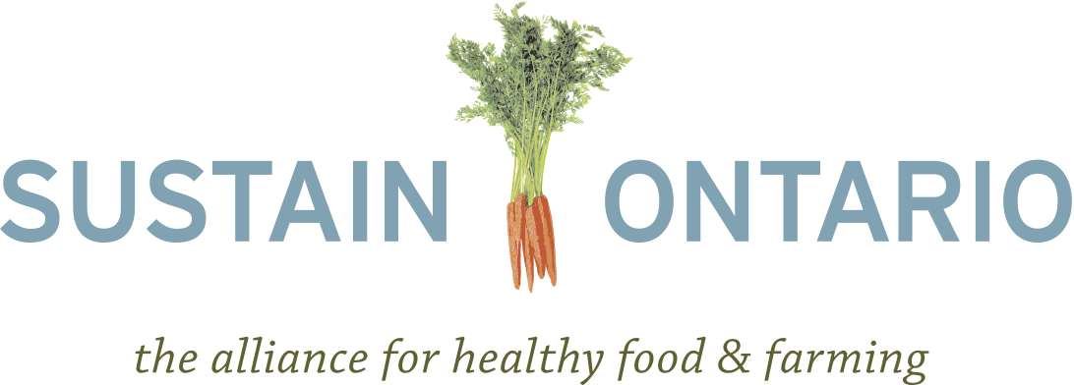

Backgrounder on Ecological Goods and Services
August 27, 2012

Introduction

This backgrounder reviews the benefits of ecological goods and services and provides recommendations for how the Ontario government can protect the ecosystems that serve Ontarians, generating economic, environmental, and social benefits.

Ecological services are life-supporting services that result from the chemical, biological, and physical interactions within ecosystems that benefit humans. These benefits, called ecological services, include but are not limited to: climate regulation, nutrient cycling, pollination, pest control, disease regulation, flood control, erosion regulation, provision of wildlife habitat, water purification and treatment. Some other less tangible ecological services, known as cultural services, include spiritual fulfillment, aesthetic value, and ecotourism.

Ecological goods are the tangible goods that are produced from ecological services and processes. These include fuel, fiber, wood, water, and food. Unlike ecological goods, ecological services are not currently valued by the market, however they can be accounted for in order to better understand the costs and benefits of destroying or maintaining the capacity of ecosystems to provide these services. For these reasons, ecological services are the focus of this backgrounder and recommendations.

The Value of Ecological Services

Several initiatives have been undertaken to understand the value of ecological services in Ontario. A 2009 study commissioned by the Ministry of Natural Resources (MNR) indicates that a conservative estimate of the value of the ecological services provided by forests, open water, wetlands, beaches and agricultural lands in southern Ontario was equivalent to $84,408,863,080 annually ($2008 CAD). The study looked at such services as pollination and dispersal, atmospheric regulation, soil retention, water quality and supply and recreational and aesthetic values. According to the authors, “these services are the foundation of human well-being and they also represent a significant part of the total economic value of our landscape and economy.”

Another study looked at services provided by Ontario’s Greenbelt. This study estimated that ecological services in this region alone are worth $2.6 billion annually; this value is not currently accounted for in markets and is likely a conservative estimate due to the incomplete understanding of all of the benefits of ecosystems. It is clear from this that the benefits accrued from ecological services are significant, as are the potential costs if human impact degrades them. Additionally, the value of ecological services of the Greenbelt’s agricultural lands (including idle lands, hedgerows, and orchards) is estimated at $329 million annually. The main services derived from Ontario agricultural lands include pollination, carbon storage in soils, and the cultural value of agricultural lands.

How do Ontario farms contribute to ecological goods and services?

In addition to being a local food source and a major economic driver for Ontario, farms and agricultural lands can also provide ecological services. For example, Greenbelt agricultural lands are responsible for storing 40 million tonnes of carbon worth $157 million per year. The services provided by hedgerows (carbon sequestration, erosion control, nutrient cycling, soil formation, and pollination services) are valued at $12 million annually. Idle farmlands provide valuable ecological services, similar to those received from hedgerows. Further, ecological farming practices help to further increase soil carbon, biodiversity and habitat, and water filtration.

Ecological services accrued from farming benefit not only farmers, but also the entire population in the form of environmental quality, recreation, and aesthetic value. However, not all farming practices equally support and benefit ecological services. Fossil-energy intensive farming can lead to leaching of soil nutrients, pesticides entering the ground or surface water, and loss of habitat. Social, economic, and environmental pressures often lead farmers to choose fossil-energy intensive farming practices over those that have ecological services benefits. Without adequate supports and system changes, it can be very difficult for farmers to adopt practices that conserve ecological services.

How are ecological services being threatened?

According to the Millennium Ecosystem Assessment, across the globe ecological services are being degraded and used inefficiently . Some evidence in the study suggested that changes in ecosystems are likely to have a domino effect within the ecosystem to the detriment of humans, including disease re-emergence and alterations in water quality. Furthermore, the effects of the degradation of ecosystems and their services have disproportionate effects on vulnerable populations and contribute to growing disparities and inequities.

In Ontario specifically, changes in land use have resulted in the loss of agricultural lands, which are often converted into urban areas. Land development has resulted in the loss of important ecosystems in Ontario that provide significant services. More than 70% of the original wetland coverage across southern Ontario has been lost and land development was a significant cause of this loss in the Golden Horseshoe. As stated above, the loss of these ecosystems and their services has many significant implications for Ontarians.

Recommendations

Continue, expand, and strengthen the Environmental Farm Plan (EFP)
- Support environmental cost-share programs that help farmers implement plans under the EFP
- Develop further initiatives aimed at increasing voluntary environmental awareness and protection
- Support, through the EFP cost share programming, conversion from conventional to organic and ecological growing techniques

Develop and champion mechanisms to support farmers in providing ecological goods and services that result from ecological farming activities, farmland preservation and wildlife preservation.
- Build on the successes of community-based models- like ALUS and other programs.
- Develop quantification techniques to accurately value ecological services from farmland and ecological farming activities.
- Develop tracking mechanisms and third party certification of the value of ecological services
- Engage the farm community in becoming effective managers of restoration sites important for environmental wellness.
- Encourage and champion programs that take a “multi-functionality” approach to delivering EG&S
- Take a whole farm approach to evaluating ecological services.

Support farmers who contribute to endangered species preservation
- Establish a system for creating voluntary, time-limited safe-harbour stewardship agreements that ensure that if a landowner restores habitat for an endangered species, they will retain the option of undoing those actions at a later date.
- Ensure that these agreements cover “incidental take” (harm to a species) that may occur throughout the duration of the agreement
- Implement off-setting for overall benefit under the Endangered Species Act.

Support Ecological and Organic Farming
- Recognize that fossil-energy intensive farming practices rely on non-renewable and ecologically harmful inputs and can result in loss of biodiversity and harmful human and environmental health impacts
- Expand support for ecological farming practices that aim to protect human and environmental health and ecological services, and maintain biodiversity and soil fertility.

Goldman, R. (2010). Ecosystem services: how people benefit from nature. Environment Magazine , 52 (5), 15-23.
Millennium Ecosystem Assessment. (2005). Ecosystems and human well-being: synthesis. Washington D.C.: Island Press.
Goldman, 2010
Puddister, M., & Koveshnikova, T. (2011). The value of ecological goods and services in the credit river watershed: the implications for greenbelt restoration.
Spatial Informatics Group, Austin Troy & Ken Bagstad, (2009). Estimating Ecosystem Services in Southern Ontario, commissioned by the Southern Region Planning Unit of the Ontario Ministry of Natural Resources
David Suzuki Foundation. (2008). Ontario's wealth, Canada's future: appreciating the value of the greenbelt's eco-services. Vancouver: David Suzuki Foundation.
Ibid.
Ibid.
Ibid.
Ibid.
Jackson, L. E., Pascual, U., & Hodgkin, T. (2007). Utilizing and conserving agrobiodiversity in agricultural landscapes. Agriculture, Ecosystems & Environment , 121, 196-210.
Ibid.
Ibid.
Millennium Ecosystem Assessment, 2005
Ibid.
Ibid.
David Suzuki Foundation, 2008 and Ducks Unlimited Canada. (2010). Southern Ontario wetland conversion analysis. Ontario: Ducks Unlimited Canada
Agriculture, Pecheries et Alimentation Quebec, (2005). · Encourage and champion programs that take a “multi-functionality” approach to delivering EG&S. Quebec: Government of Quebec
Jackson, L. E., Pascual, U., & Hodgkin, T. (2007).

