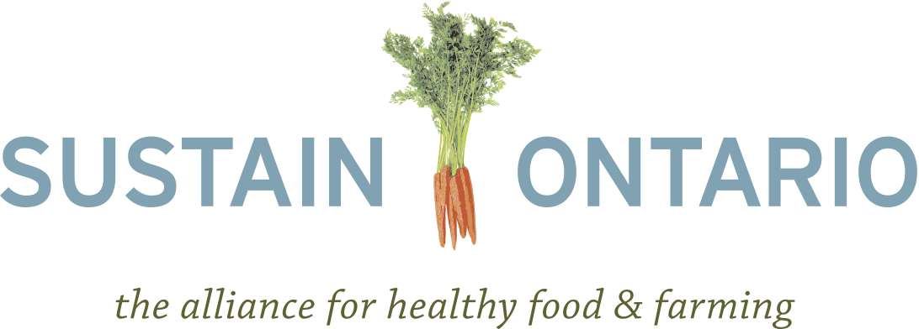

Draft Backgrounder On Land Use Planning For Food Access, Agricultural Land Preservation And Food Production

Introduction

This backgrounder reviews some of the essential contributions that land use planning for food access, agricultural land preservation and food production can make toward the economy, environmental stewardship, public health and ensuring a successful food system for the future. It concludes with recommendations for the inclusion of land use planning policies into the proposed Local Food Act.

How does land use planning for food access, agricultural land preservation and food production contribute to a better Ontario?

Economy

Land use planning for agricultural land preservation supports Ontario’s economic present and future by ensuring a viable land base for food production, secure employment opportunities, and steady revenue and economic growth. In addition, branding and marketing food grown and produced in Ontario is a successful economic tool, as food grown in Ontario is known internationally for its safety and quality.

As well, land use planning for urban and peri-urban agriculture is an innovative solution to the rising age of farmers and the growing demand for local food. Ramping up agricultural operations within cities is supportive of the direction in which many new farmers wish to take agriculture, produces a high-demand product, educates the public about food production, and encourages urban youth to consider farming as a career.

Environmental Stewardship

Protecting prime and peri-urban agricultural lands is an important way to both ensure a viable agricultural sector for future generations and adapt to the projected impacts of climate change. And yet in Ontario today, urban boundary encroachments, non-farm usage, land speculation and lot-by-lot severances are consuming prime agricultural land at a rapid rate. In 2001, half of the country’s urbanized land was already located on prime agricultural land. Planning policy that protects prime agricultural land ensures not only that the sector has a land base on which to operate for the future, but also serves the purpose of urban containment and facilitates the transition to “smart growth” in cities. Planning policy should also recognize that agricultural land maintains the environmental health and ecological integrity of a region and makes possible adaptation to the impacts of climate change.

Public Health

When food system planning provides people with access to healthy, fresh and local foods, it contributes to healthy eating choices and the achievement of broader public health objectives. It also encourages a more active lifestyle when food destinations are within easy walking distance of where people live and work.

Land Use Planning for the Future

The Local Food Act should investigate and modify severance clauses in the Planning Act with an interest in keeping farmland in production and maintaining cohesive and sustainable rural communities. Policies must be flexible enough to protect the interests of farmers both present and future. It should recognize that a farmer today may wish to expand their farming operation into new lots without becoming a residential landlord but that a future farmer on the property may require the previously severed farm dwelling. The Local Food Act should recognize that the permanent separation of farmstead from farmland might be a shortsighted solution.

Recommendations

The Local Food Act should amend the Planning Act on the following points:
- In preparing and/or reviewing planning studies, development applications and site plans, the region or municipality should ensure that the development facilitates residents’ access to locally grown and other healthy foods.
- Ensure that retail food outlets selling healthy foods exist within walking distance of all community members.
- Support urban agriculture as an economic enterprise, as a form of employment and as a permitted use of open space.
- Municipalities should permit temporary farmers’ markets, where appropriate, particularly in areas where access to fresh food may currently be limited.
- Municipalities should establish policies in their official plans that encourage community gardens and rooftop gardens. They should support community gardens by providing land, rain barrels, composting bins, and other required items.

Investigate and modify severance clauses to prioritize keeping farmland in production and maintaining cohesive and sustainable rural communities.

Establish a hierarchy of priorities within the Provincial Policy Statement (PPS)
- As all current PPS policies are to be given equal priority, the document is difficult to navigate and often contradictory. Policies that provide more protection to the natural environment and human health should be prioritized over others.

Protect prime agricultural land
- Halt the loss of prime agricultural land due to settlement area expansions and aggregate operations. Protect prime agricultural land by promoting its use for agricultural purposes and normal farm practices.
- Expand the Greenbelt in the Places to Grow Act to reduce development of significant agricultural lands.
- Rehabilitate aggregate sites on prime agricultural land so as to restore the same acreage and soil capability as was present prior to extraction.
- Provide financial and technical assistance to farmers and other rural landowners/managers to maintain and enhance ecologically and hydrologically important features on their land.
- Provide easements and incentives for farmers who participate in conservation activities and use best practices and management.
- Recognize prime agricultural lands as a component of natural heritage systems.

Create an environment favourable to regional food processing
- Establish food safety regulations appropriate to the scale of processing enterprises and support for compliance.
- Stimulate agricultural processing enterprise zones to extend tax relief and credits to food processors.
- Investigate and modify definitions of value added versus value retention agricultural activities to support farmers in using land for necessary secondary agricultural uses while at the same time working to keep farmland in production as much as possible.

Young, C. 2005. “Five Year Review of the Provincial Policy Statement.” Guelph, ON: FarmStart.
Greenbelt Task Force. 2004. “Advice and Recommendations to the Minister of Municipal Affairs and Housing.” Ministry of Municipal Affairs and Housing.
Hofman, N., Filoso, G. and Schofield, M. 2005. “The Loss of Dependable Agricultural Land in Canada.” Rural and Small Town Canada Analysis Bulletin. Vol. 6, No. 1.
Lee, M., Barbolet, H., Adams, T. and Thomson, M. 2010. “Every Bite Counts: Climate Justice and BC’s Food System.” Vancouver, BC: Canadian Centre for Policy Alternatives.
Region of Waterloo. 2010. “Regional Official Plan.” Region of Waterloo and the Ministry of Municipal Affairs and Housing.
Young, 2005.
Region of Waterloo, 2010.
Young, 2005.
Young, 2005.
Region of Waterloo, 2010.
Region of Waterloo, 2010.
Ontario Nature et al. 2010. “Submissions of Planning for Sustainability: A provincial policy statement collaborative in response to the on-going review of the Provincial Policy Statement 2005.”
Ontario Nature et al., 2010.
Burda, C. 2008. “Getting Tough on Urban Sprawl: Solutions to meet Ontario climate change targets.” Drayton Valley, Alberta: The Pembina Institute.
Ontario Nature et al., 2010.
Ontario Nature et al., 2010.
Greenbelt Task Force, 2004.
Ontario Nature et al., 2010.

