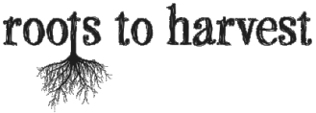
Exploring Food Miles
This game is a fun, energetic way to think about food miles. ‘Food miles’ refers to the distance food travels between farm and consumer. A carrot, for example, from a local farm, has very low food miles, whereas a banana from South America has high food miles.
Purpose | To explore the concept of ‘food miles’  Things to consider:  What are the benefits of buying food with low miles? (Examples: apples, carrots, potatoes, beef)  - Buying regionally and provincially produced food supports the local economy  - You are able to see where and how your food is being produced  - Food can be harvested when it is ripe and full of nutrients, and will not spoil before making it to the market  What are the benefits of buying food with high miles? (Examples: Bananas, most fruit, seafood, sugar, salt, coffee, chocolate)  - We can have a variety of foods that cannot grow here  - We can have enough food  - It would take more effort and resources to grow some foods in our climate
Materials | - Cheerios or another hoop shaped cereal  - Spaghetti (1-2 sticks per student)  - Bowls (2 per team - 3-5 students per team)
Directions | - Divide the class into teams of around 4 students. Each team should have room to move in an imaginary lane from one end of the room to the other.  - Place an empty bowl for each team at one end of the classroom and a bowl full of Cheerios for each team at the other side.  - Give each student a piece of spaghetti.  - Give each group a different meal card. Introduce each meal. Talk about the ingredients and where they come from.  - Give the students a time limit (5-10 min). Explain the goal of the game: to get as many Cheerios as possible from one bowl to the other, BUT they can only use the spaghetti (no fingers, hands or other body parts) and can only bring 1 Cheerio at a time.  - When time has expired have students count how many Cheerios they successfully transported. And finally, how many of the teams can make their meal?
Example follow up questions | - What did you eat for breakfast? How far do you think it had to travel?  - Which meal required the most travel/work?  - Imported food is more abundant and sometimes cheaper (even though it takes more work to get it here). How is this possible? Why is this so?
Exploring Food Miles - Meal Cards
(Adapt the cards to add the names of local farms if possible)

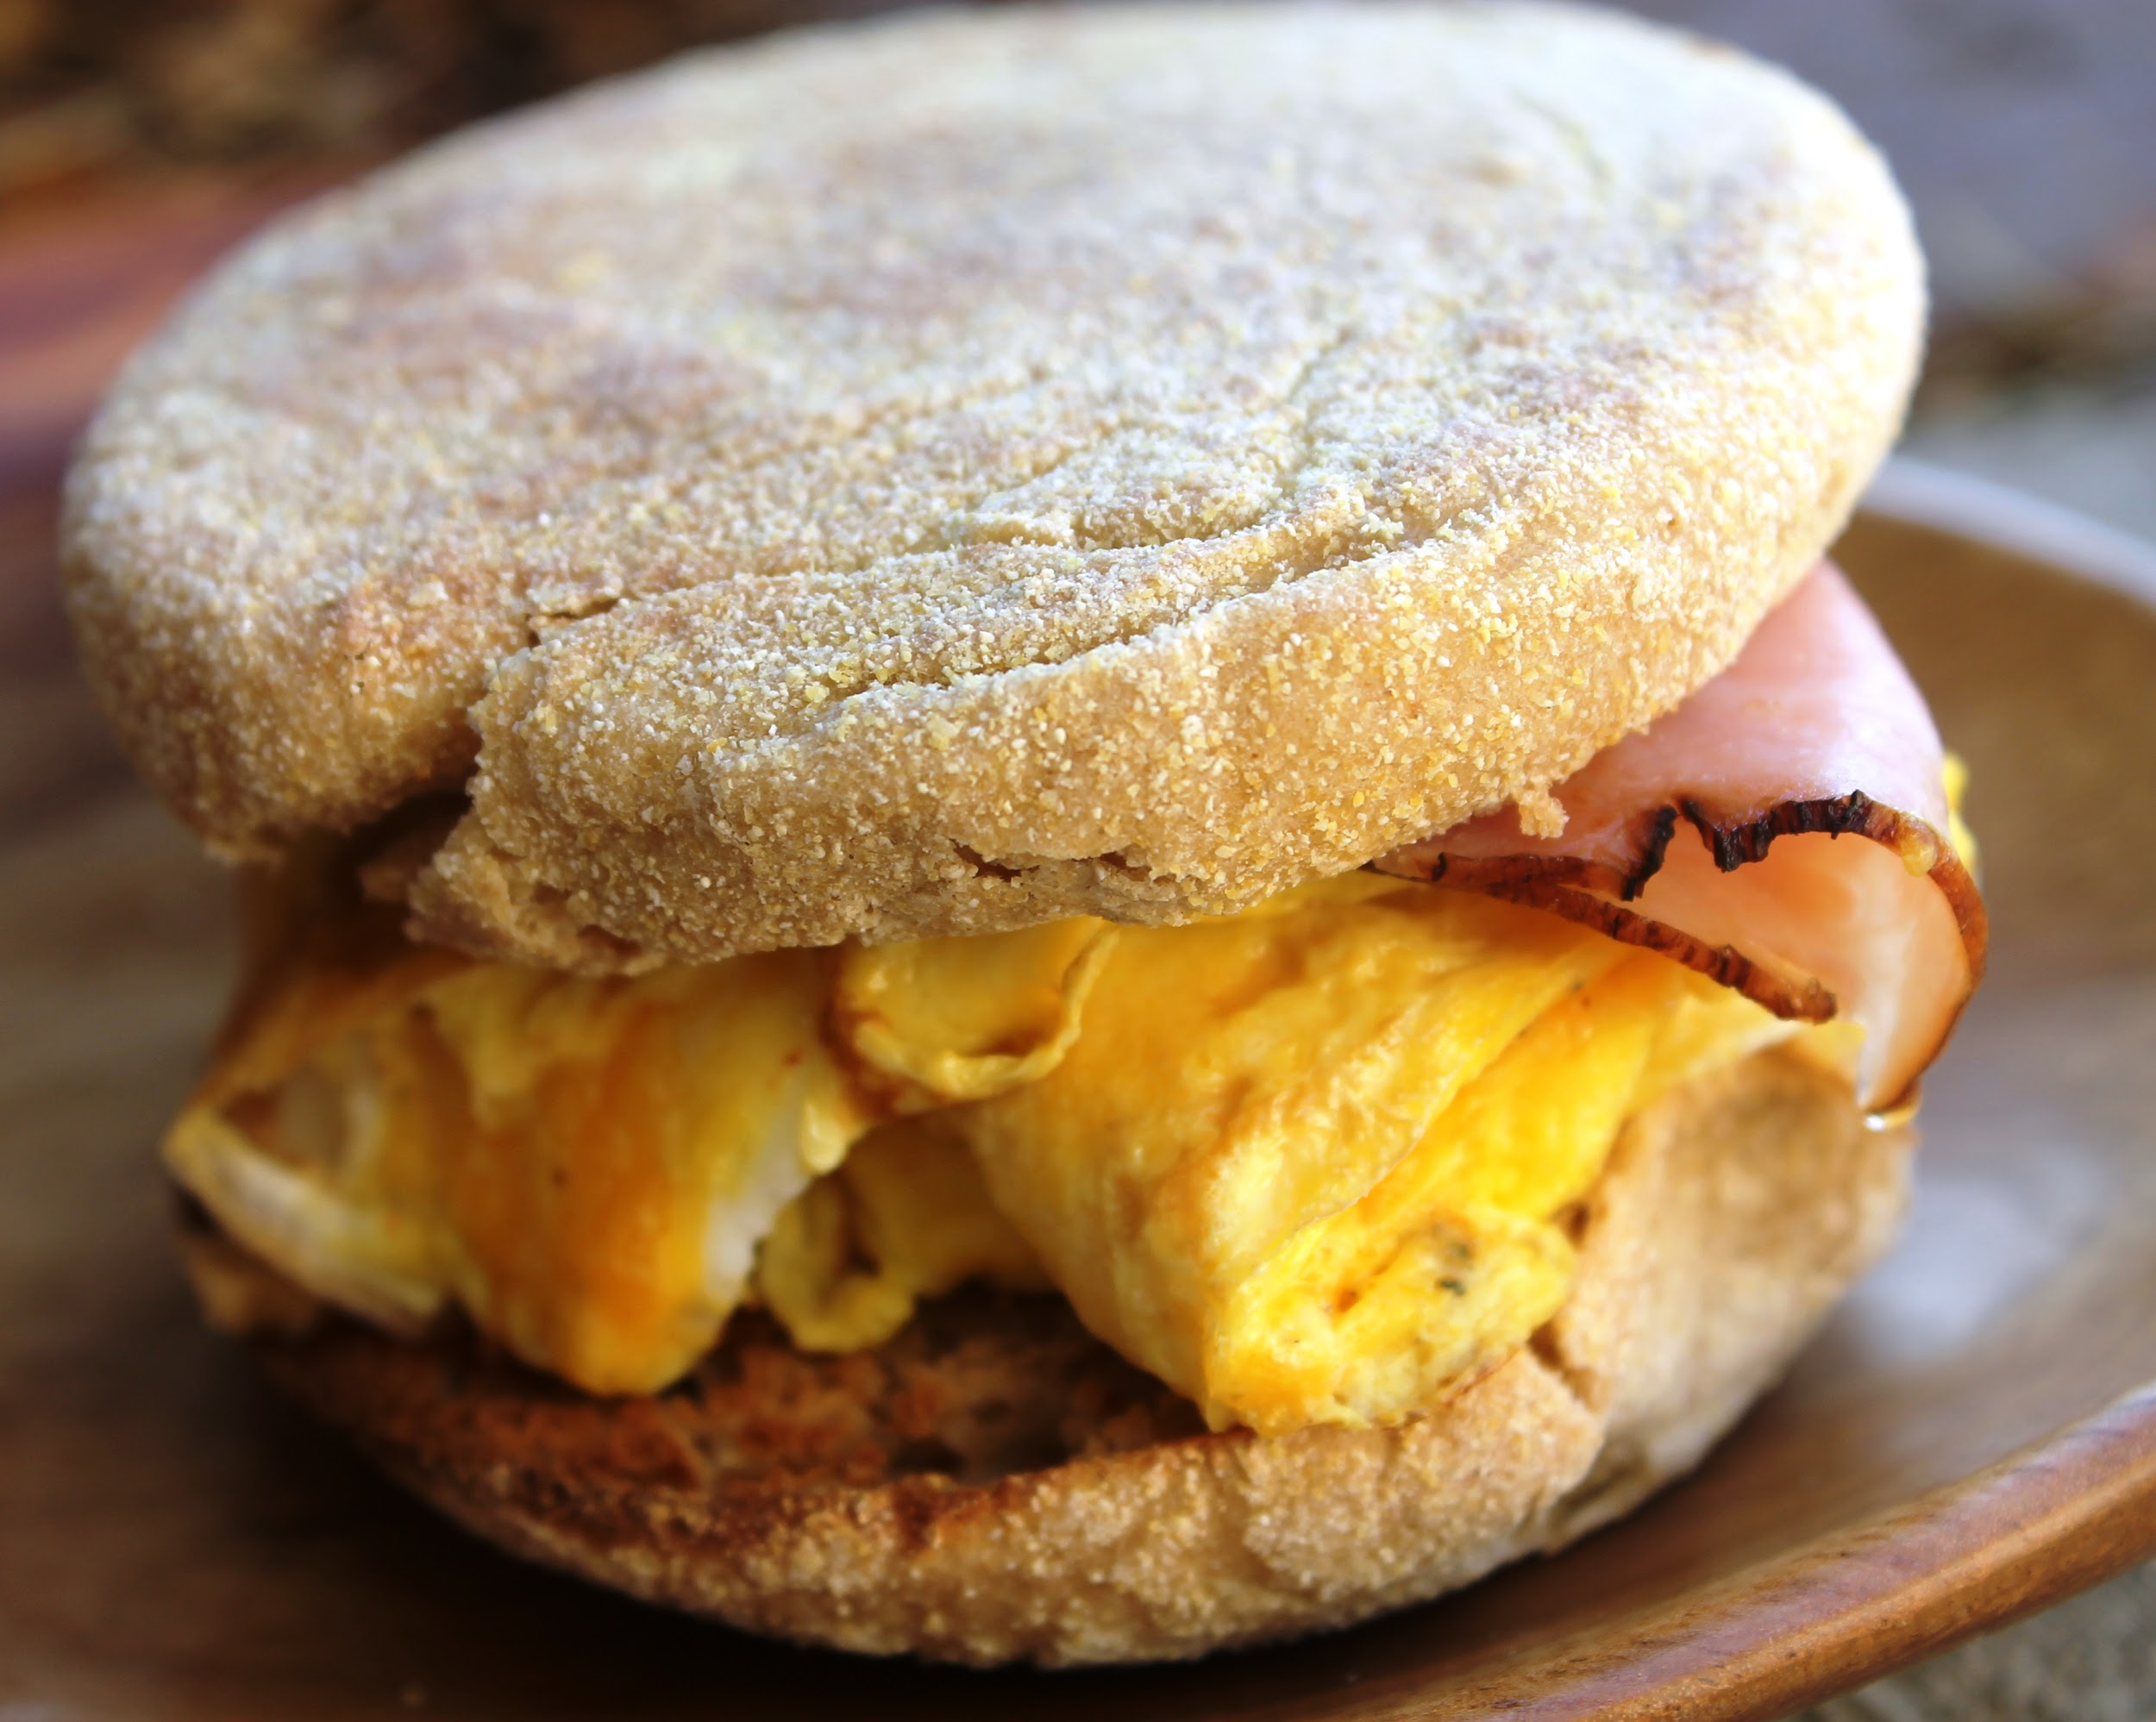
Local
Egg and Ham Sandwich
- Eggs from a local farm (2)
- Ham from a local farm (2)
- Cheese from a local farm (2)
- English Muffin - wheat from Alberta (5)

Total = 11 Cheerios per meal

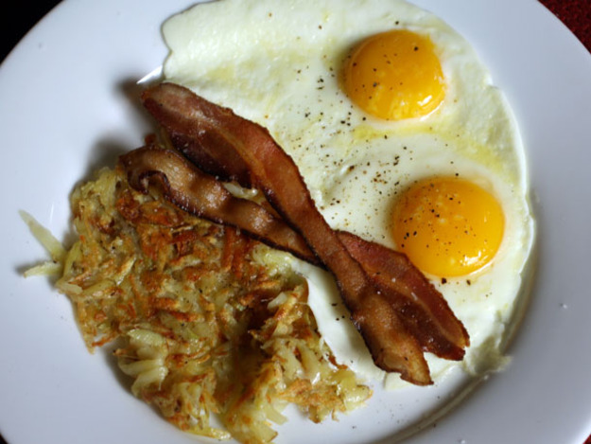
Kind of Local
Eggs with Bacon and Hashbrowns
- Eggs from an Ontario producer (5)
- Bacon from Maple Leaf (5)
- Potatoes from a local farm (2)
- Onions from a local farm (2)

Total = 14 Cheerios per meal

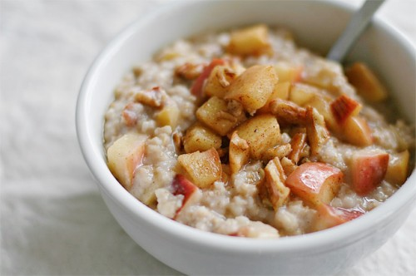
Canadian
Oatmeal with Apple and Maple Syrup
- Oats from Saskatchewan (5)
- Apples from BC (10)
- Maple syrup from Quebec (3)

Total = 18 Cheerios per meal

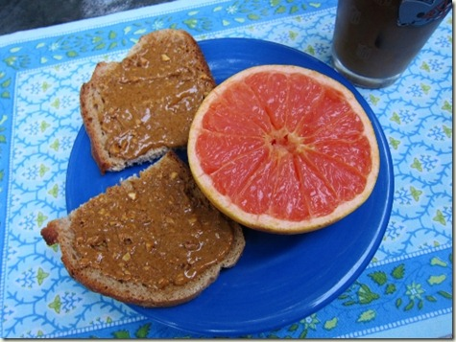
North American
Grapefruit with Peanut Butter Toast
- Grapefruit from Florida (10)
- Peanuts from Virginia (10)
- Bread from local Bakery (2)

Total = 22 Cheerios per meal

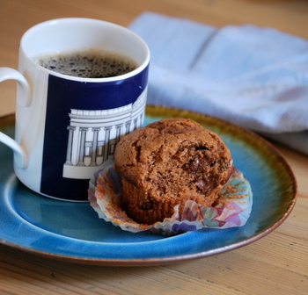
Intercontinental
Coffee with Banana Muffin
- Coffee beans from Columbia (15)
- Bananas from Costa Rica (15)
- Wheat from Alberta (5)

Total = 35 Cheerios per meal

