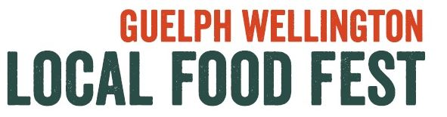
VENDOR SURVEY
1. Why did you sign up for this event (check all that apply)
- Interested in meeting new contacts
- Participated in previous years
- Looking for new customers
- To sell product
- Interested in community outreach
Other ( Please specify)___________________________________________________

2. Was this event worth your while: (please circle)
Was this event worthwhile for your business/organization? Yes No
Was the cost of participation reasonable for the value you got? Too high Just Right Too Low
Would you recommend this event to other vendors/exhibitors? Yes No
Would you attend this event again as a vendor/exhibitor? Yes No
Would you be interested in assisting in organizing the 2016 event? Yes No Ask me again later
Comments:___________________________________________________________________________________
_____________________________________________________________________________________________

3. Please rate the logistics of this event: (please circle)
Location Good Somewhat difficult Very difficult
Time of day Good Somewhat difficult Very difficult
Arrival and setup Good Somewhat difficult Very difficult
Advance notice about the event Good Somewhat difficult Very difficult
Vendor details for the event Good Somewhat difficult Very difficult
Submission of forms and menus Good Somewhat difficult Very difficult NA
Registration process Good Somewhat difficult Very difficult
Comments:___________________________________________________________________________________
_____________________________________________________________________________________________
4. Overall, how would you rate this event?
- Great
- Good
- Somewhat poor
Comments:___________________________________________________________________________________
_____________________________________________________________________________________________

5. What did you like most about the event?

6. What could be done differently and how would it improve your/our patrons’ experience?

7. Did you promote this event within your Network? Yes No
If yes, how:

8. Any other feedback or suggestions are greatly appreciated including additional vendor suggestions for next year!!

Name:
Booth Name:

Thank you for participating in the LOCAL FOOD FEST!

